Breaking the Upper Bound of Siloxane Uptake: Metal-Organic Frameworks as an Adsorbent Platform

Ezgi Gulcay*,1, Paul Iacomi*,1, Youngsang Ko2, Jong-San Chang2, Guillaume Rioland3, Sabine Devautour1, and Guillaume Maurin1,✉

Biogas, regarded as a promising renewable energy source, still needs to be upgraded. This calls for the removal of the most prominent contaminants, among others the octamethylcyclotetrasiloxane (D4) molecule. Herein, high throughput computational screening in tandem with synthesis and adsorption testing revealed the hydrophobic Zr-MOF PCN-777 as an optimal D4 adsorbent with record gravimetric (1.8 g/g) and volumetric (0.49 g/cm3) uptakes, alongside a reversible and fast adsorption/desorption process, good cyclability and easy regeneration. This MOF was demonstrated to encompass an ideal combination of mesoporous cages and chemical functionality to enable an optimal packing of the siloxane molecules and their efficient removal while maintaining the process highly reversible thanks to moderately high host/guest interactions. This work highlights the efficacy of an integrated workflow for accelerating adsorbent selection for a desired application, spanning the entire pipeline from method validation to computational screening, synthesis and adsorption testing towards the identification of the optimal adsorbents.

* These authors contributed equally to this work.

1 ICGM, Univ. Montpellier, CNRS, ENSCM, F-34095 Montpellier, France  
2 Research Group for Nanocatalyst (RGN) and ConvergentCenter for Chemical Process (CCP), Korea Research Institute of ChemicalTechnology (KRICT), Gajeong-ro 141, Yuseong-gu, Daejeon 34114, South Korea  
3 Centre National d’Etudes Spatiales, DSO/AQ/LE, 18 AvenueEdouard Belin, 31401 Toulouse, Cedex 09, France

✉ Correspondence: [Guillaume Maurin <guillaume.maurin1@umontpellier.fr>](mailto:guillaume.maurin1@umontpellier.fr)

# Introduction

Biogas capture from landfill sites or wastewater treatment plants is identified as an appealing strategy to procure a renewable energy fuel, simultaneously promoting a reduction in greenhouse gas emissions and an increase in waste treatment profitability [1]. The use of biogas as an energy green resource critically calls for a substantial increase of its $CH4$ quality by removing gaseous and vapour impurities resulting from anaerobic digestion processes [1]. One prominent class of biogas impurities are the linear (denoted “L”) and cyclic (denoted “D”) siloxanes, as degradation by-products of silicone polymers from packaging, construction, cosmetics, and household items [2], [3]. This family of molecules is also known to damage subsequent energy recovery systems, e.g. combustion engines, fuel cells and steam reformers, via their decomposition into amorphous silica on heated surfaces that leads to abrasive solid deposits on critical machinery, and to inactivation of gas reforming catalysts [4]. Octamethylcyclotetrasiloxane commonly labelled D4 is the most representative siloxane species present in biogas, which spans from 50 to 70% of the total siloxane content due to its relatively low water solubility (56 μg/l) and its significant vapour pressure (196 Pa at 303 K) [3]–[5].

Multiple technologies have been proposed to mitigate the presence of siloxanes in biogas outlet streams, including mineral acid/base scrubbing, deep chilling, or iron oxide beds, often working in tandem to remove other impurities [6]. The physisorption-based removal of D4 by porous filters is also a promising alternative, due to its relatively low potential energetic cost, while avoiding the use of environmentally hazardous chemicals [7], [8]. A variety of conventional adsorbents has been envisaged for siloxane elimination, including activated carbons [9], zeolites [10], and silicas [11]. However, these materials suffer from several drawbacks that limit their use, in particular insufficient uptake and/or incomplete regeneration under standard conditions. Moreover, downstream biogas commonly contains a proportion of water, which can compete with D4 sorption when using hydrophilic adsorbents [6], [12]. Therefore, finding a high capacity adsorbent capable of removing siloxanes under moderate humidity conditions in a reversible manner remains a challenge.

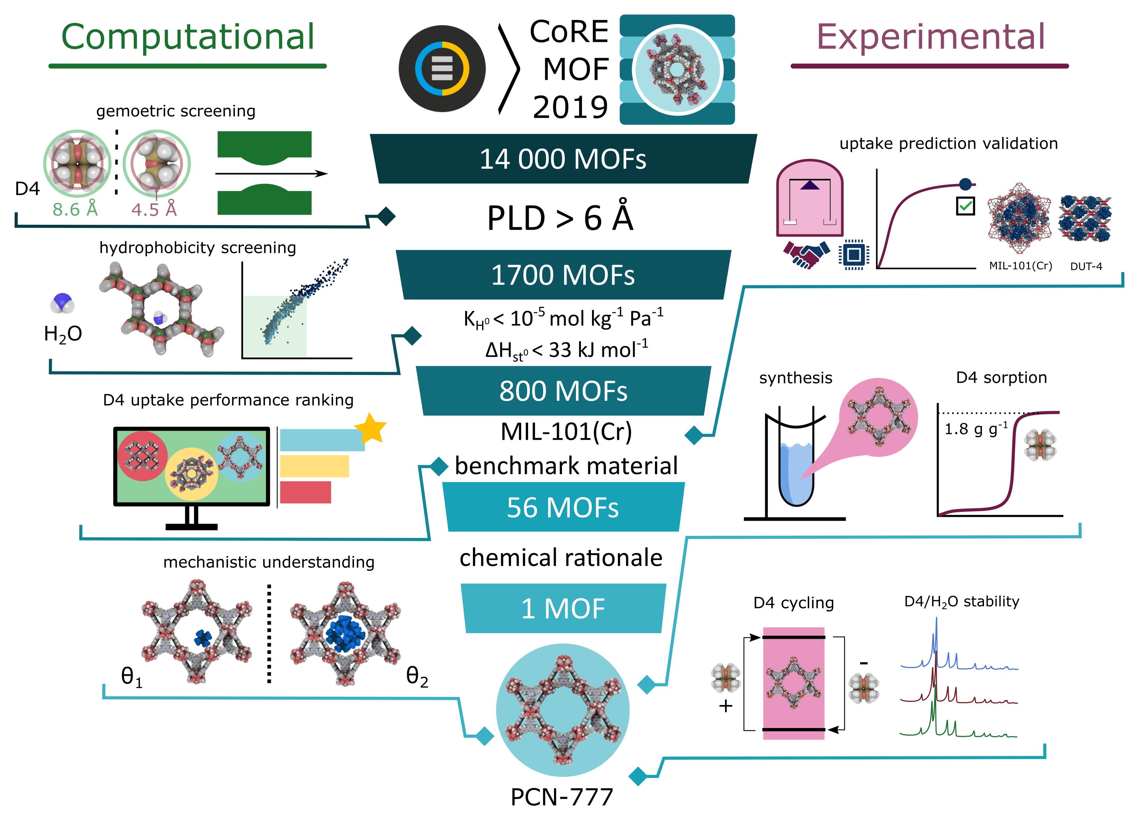

Figure 1: Workflow of the strategy applied to identify the best MOFs for D4 adsorption, narrowing down candidates from top to bottom through synergistic computational (left) and experimental (right) actions. The final MOF candidate, PCN-777, is highlighted.

Metal-Organic Frameworks (MOFs) are one of the most recent classes of porous adsorbents. These coordination polymers are built from the assembly of metal nodes and organic multidentate linkers to form architectures of different dimensionality from 1D to 4D [13]–[15]. Their near-infinite diversity, thanks to a wide set of building blocks, has made this class of porous solids promising for applications in gas/vapour adsorption/separation [16], [17], catalysis [18], and sensing [19], [20] among others. Their high and uniform porosity combined with extensive chemical tunability of their pore walls suggest that MOFs may hold promise as candidates for siloxane adsorption. Insofar only two studies have attempted to investigate the potential of MOFs for D4 removal. Mito-Oka and co-workers [21] proposed DUT-4 ($[Al(OH)(2,6−ndc)$, DUT: Dresden University of Technology), a wine rack-like MOF, as a first potential adsorbent. Although its hydrophobicity makes this MOF attractive for D4 elimination under humidity, its adsorption capacity of 0.15 g/g, estimated through single component by TGA measurements, is rather low and its regeneration can only be achieved at very high temperature, over 523 K, resulting from a high confinement of D4 (kinetic diameter of 8.6 Å) in its channels (9 Å × 9 Å). More recently, MIL-101(Cr) ($Cr3O(OH)(H2O)2(btc)3$, MIL: Material of Institute Lavoisier), a well-known highly porous MOF incorporating two types of mesoporous cages with diameters of 29 Å and 34 Å was demonstrated to exhibit a much higher D4 uptake of 0.95 g/g at 298 K, however its regeneration was only possible upon heating at 423 K under vacuum [22]. Further, since MIL-101(Cr) is known to be highly hydrophilic [23] we can expect a substantial drop of its D4 uptake performance even under low-relative humidity. Indeed, neither of these MOFs tested so far combines a large D4 uptake, low-energy regeneration and hydrophobicity to avoid a preferential adsorption of $H2O$ over D4 under low to moderate relative humidity.

To date, only a very small number of MOFs has been sampled for this application, and therefore relied on researchers’ intuition to identify promising adsorbents. There are, however, a myriad of hydrophobic MOFs that can potentially perform better for D4 adsorption. Since it is unfeasible to individually test the performances of all the existing MOFs, several high throughput computational screening (HTCS) workflows have been devised which identified promising MOFs for diverse adsorption-related applications [24]–[29]. However, such a computational strategy can only be successful if conducted in strong interplay with a careful analysis of the best-predicted MOF performers in terms of chemical/thermal stability under the target working conditions as well as ease of synthesis/activation. This enables the selection of the MOF candidate with the best overall compromise for further adsorption testing to confirm the expectation.

With this in mind, we herein devise a hand-in-hand computational-experimental strategy whose workflow is summarized in fig. 1. As a first stage, the CoRE (Computation-Ready, Experimental) MOF 2019 database [30] was computationally screened with the objective to identify hydrophobic materials showing a D4 uptake higher than the current MOF benchmark, e.g. MIL-101(Cr). From the top 56 best MOF performers, we selected the Zr carboxylate-based mesoporous PCN-777 (PCN for Porous Coordination Network) for further experimental testing. This MOF was demonstrated to exhibit not only a record D4 uptake (1.8 g/g) to date for a crystalline porous material, but also exceptional cycling and low-energy regeneration without the need for thermal treatment, while its confirmed hydrophobicity strongly suggests a preservation of its adsorption performance under low to moderate relative humidity conditions. An in-depth analysis of the adsorption mechanism further revealed the dominant host-guest interactions that control the adsorption of the first D4 molecules and their effective packing in the whole porosity up to saturation.

# Methodology

## Computational methods

The CoRE (Computation-Ready, Experimental) MOF 2019 database [30] was considered in this work. The geometric characterization of MOFs, including pore limiting diameters (PLDs), densities, $N2$-accessible surface areas (SAs), pore volumes (PVs) and void fractions ($ϕ$), were calculated by Zeo++ software [31]. All Monte Carlo simulations were performed with the RASPA simulation package [32]. Henry coefficients of $H2O$ ($K_{H,H_{2}O}$) and isosteric enthalpy of adsorption ($ΔH_{st,H_{2}O}^{0}$) values were initially computed at 298 K for all MOFs using the Widom particle insertion method [33]. These simulations were carried out using 1 × 105 production cycles and 5 × 104 cycles for equilibration. We applied the same Widom insertion method to calculate isosteric enthalpy of adsorption at low coverage for D4 in DUT-4 and PCN-777 with the consideration of 1 × 106 production cycles and 5 × 105 steps for equilibration. Continuous fractional component Monte Carlo (CFCMC) simulations were performed to evaluate the saturation D4 uptake of all the selected hydrophobic MOFs at 298 K. All CFCMC simulations were carried out for a total of 1 × 104 cycles with 5 × 103 cycles for equilibration. A cycle consists of N Monte Carlo steps, where N is equal to the number of molecules (which fluctuates during a CFCMC simulation). For each cycle, random insertion, rotation, translation and continuous-fractional swap moves were attempted. The D4/MOF and $H2O$/MOF interactions were described by the sum of van der Waals (LJ) and Coulombic terms. The electrostatic interactions were calculated by the Ewald summation [34] while a cut-off radius of 12.8 Å was considered for the van der Waals term. Cell lengths of the simulations were increased to at least 25.6 Å in each three dimensions and all MOF frameworks were considered as rigid in the simulations. Atomic charges for all atoms in the MOFs were estimated using Extended Charge Equilibration (Qeq) method as implemented in RASPA [32] and their LJ parameters were taken from the UFF forcefield as currently employed [35], [36]. H2O was modelled using TIP4P/2005 [37]. D4 was described by a semi-flexible all atom model with intramolecular parameters taken from the consistent-valence force field (CVFF) [38] (tbls. 2-6, SI) while the LJ parameters for all atoms were taken from the UFF forcefield as done in earlier work [39] and their charges were calculated at the DFT level (tbl. 7, SI).

All the results of the HCTS are available as CSV files in the SI. A web-based explorer, which can be used to interactively display the dataset is available at <https://pauliacomi.com/mof4d4>.

## MOF sorbents

The benchmark MIL-101(Cr) sample was taken from a previous work [40], with all textural characteristics as stated in reference. DUT-4 was purchased from Materials Center (TU Dresden, Germany). PXRD, TGA and $N2$ physisorption measurements for DUT-4 are available in the SI (fig. 10). BET surface areas of 3475 m2/g and 1610 m2/g were determined for MIL-101(Cr) and DUT-4, respectively. PCN-777 was synthesised by optimizing a previous published methodology [41]. Full synthesis methodology, activation procedure and phase purity analysis using TGA, PXRD and $N2$ physisorption are given in the SI. All samples were activated at 423 K under vacuum adsorption experiments.

## Material characterization

PXRD patterns were recorded on a Panalytical X’Pert PRO PXRD diffractometer with a Cu $K_{α}$ radiation source, in a Bragg-Brentano reflection geometry, using a spinning sample holder with a low-background silicon insert. $N2$ isotherms at 77 K were recorded in a Micromeritics Tristar manometric analyser (displayed in fig. 12, SI). The Brunauer-Emmet-Teller area was calculated using the pyGAPS suite [42], with the application of the Rouquerol rules for isotherm region selection yielding a minimum Pearson correlation coefficient of $R=0.997$ (see fig. 13 for resulting fitting).

## D4 sorption experiments

Sorption measurements were gravimetrically recorded using a dynamic method in a DVS Vacuum instrument (Surface Measurement Systems, UK). In this setup, a continuous adsorbate flow sourced from the headspace of a reservoir enters the sample enclosure, passes the suspended sample pan, and is entrained by a vacuum system. Pressure is controlled by a butterfly valve located before the outlet. Uptake is monitored by a magnetically suspended balance, capable of measuring mass changes at a resolution of 0.1 μg. The entire apparatus is kept in a temperature-controlled chamber to avoid any condensation points. For each experiment, a stainless-steel sample pan is first tared, then loaded with about 10 mg of sample. The sample is activated *in situ* under dynamic vacuum (1E-2 Pa) to 423 K. The adsorption-desorption isotherms for D4 and $H2O$ and subsequent repeats were recorded at 303 K in the 0-10 Pa range of pressure. Adsorption cycling was similarly recorded, switching between two setpoints of low (0.5 Pa) and high pressure (10 Pa). The D4 used for the sorption experiments was sourced from Sigma Aldrich, with minimum 98% purity.

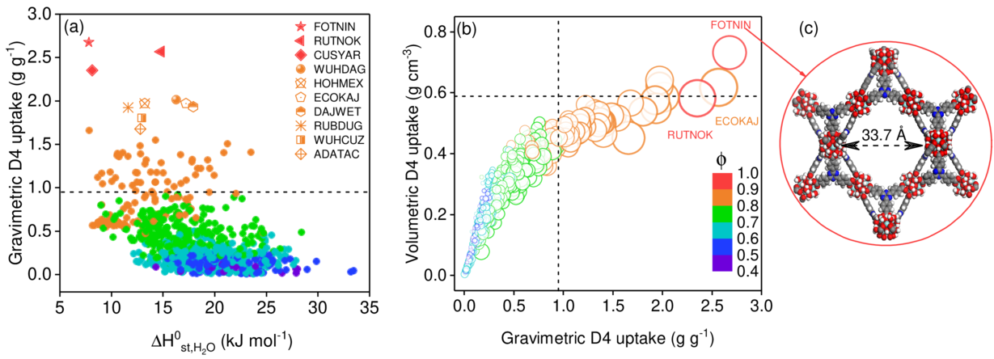

Figure 2: (a) Predicted D4 uptake performance at 298 K for the hydrophobic MOF database plotted as a function of computed $ΔH_{st,H_{2}O}^{0}$, and colour coded by void fraction, $ϕ$. Top performing 10 candidates are represented by different symbols in the legend. (b) Relation between gravimetric (g/g) and volumetric (g/cm3) D4 uptake for all MOFs at 298 K. Marker size represents PV while colour denotes $ϕ$. Dashed line represents the gravimetric and volumetric uptake of benchmark MIL-101(Cr)[22]. (c) The structure of our promising material identified for D4 uptake, PCN-777. Zr, N, O, C, and H atoms are depicted in light blue, dark blue, red, dark grey, and light grey, respectively.

# Results and discussion

## Pre-selection of hydrophobic MOFs

We used the CoRE-MOF 2019 database [30] (over 14 000 MOFs), recently updated to remove solvent molecules and disordered structures, to which we also added further 29 well-known MOFs owing to their good chemical/thermal stability and permanent accessible porosity (listed in tbl. 8 SI). We first excluded all structures with PLDs lower than 6 Å, a threshold selected as the average between the kinetic diameter of D4 (8.6 Å) and the effective diameter of its constitutive inner Si-O ring (4.5 Å). A total of 1739 remaining non-disordered MOFs were further considered, their geometric and textural properties, i.e. PV, SA, and $ϕ$, as well as their density ($ρ$) being summarized in fig. 5.

As siloxane-rich biogas streams often contain water vapour, the optimal D4 adsorbent should have a relatively low water affinity to avoid competing adsorption. Moreover, hydrophobic MOFs are known to possess increased resistance to the hydrolysis of the metal-linker bond [43], [44], alleviating long-term water stability concerns. Therefore, we screened the water affinity of the 1739 MOFs by computing their Henry coefficient of water ($K_{H,H_{2}O}$) and the isosteric enthalpy of adsorption at infinite dilution ($ΔH_{st,H_{2}O}^{0}$) at 298 K using the Widom particle insertion method [33]. This approach is generally applied in HTCS studies, providing a quick way to gauge the hydrophobicity/hydrophilicity of MOFs [35], [45]. All the computational details including the force fields used to describe both MOFs and water are provided in the methodology section and SI. In the frame of biogas upgrading, an extremely hydrophobic adsorbent is not required since the water content usually ranges from 38% to 85% relative humidity [4], therefore the following thresholds were applied to select MOFs with moderate to high hydrophobicity: < 1 × 10−5 mol/kg/Pa and $ΔH_{st,H_{2}O}^{0}$ < 33 kJ/mol (below the vaporization enthalpy of water ~40 kJ/mol) [46]. As a frame of reference, the highly hydrophobic ZIF-8 is characterized by $K_{H,H_{2}O}=$ 2.5E-6 mol/kg/Pa and $ΔH_{st,H_{2}O}^{0}=$ 30 kJ/mol [47]. Overall, among the 1739 MOFs, 811 structures (47% of our material library) were predicted to fulfill these two criteria. This hydrophobic MOF dataset encompasses structures of density ranging from 0.24 g/cm3 to 2.04 g/cm3 and with a wide range of geometric and textural features: 6 Å < PLD < 36 Å, 0.42 < $ϕ$ < 0.90, 0.27 cm3/g < PV < 3.72 cm3/g and 320 m2/g < SA < 6700 m2/g, as shown in fig. 5.

## Prediction of the D4 uptake performance for the hydrophobic MOFs

The D4 adsorption uptakes for the selected MOFs were simulated using single point continuous fractional component Monte Carlo (CFCMC) [48]. In these calculations, the framework atoms were maintained fixed in their crystallographic positions and D4 was modelled as a semi-flexible molecule with its Si-O ring maintained rigid. Full computational details, including force field parameters and partial charges for D4 are available in the methodology section and SI.

Table 1: Top 10 promising hydrophobic MOF materials identified for D4 uptake at 298 K.

|  |  |  |  |  |  |  |  |  |  |
| --- | --- | --- | --- | --- | --- | --- | --- | --- | --- |
| MOF | PLD | SA | $ρ$ | PV | $ϕ$ | $K_{H,H_{2}O}$ | $ΔH_{st,H_{2}O}^{0}$ | Gravimetric D4 | Volumetric D4 |
|  | (Å) | (m/g) | (g/cm3) | (cm3/g) |  | (mol/kg/Pa) | (kJ/mol) | uptake (g/g) | uptake (g/cm3) |
| FOTNIN (PCN-777) | 28.36 | 2990 | 0.27 | 3.31 | 0.90 | $2.80×{10}^{−6}$ | 7.82 | 2.68 | 0.72 |
| RUTNOK | 14.65 | 6200 | 0.24 | 3.72 | 0.90 | $6.70×{10}^{−6}$ | 14.81 | 2.57 | 0.62 |
| CUSYAR | 12.18 | 5700 | 0.25 | 3.65 | 0.90 | $3.42×{10}^{−6}$ | 8.15 | 2.35 | 0.59 |
| WUHDAG | 10.50 | 5500 | 0.29 | 2.99 | 0.87 | $4.69×{10}^{−6}$ | 16.28 | 2.01 | 0.58 |
| HOHMEX | 14.89 | 5000 | 0.32 | 2.74 | 0.87 | $4.66×{10}^{−6}$ | 13.24 | 1.97 | 0.63 |
| ECOKAJ | 17.58 | 3600 | 0.33 | 2.68 | 0.87 | $6.89×{10}^{−6}$ | 17.20 | 1.97 | 0.65 |
| DAJWET | 26.59 | 5000 | 0.28 | 3.06 | 0.87 | $7.73×{10}^{−6}$ | 17.92 | 1.93 | 0.54 |
| RUBDUP | 19.25 | 4200 | 0.30 | 2.90 | 0.87 | $3.79×{10}^{−6}$ | 11.62 | 1.93 | 0.58 |
| WUHCUZ | 12.21 | 5500 | 0.30 | 2.91 | 0.87 | $3.75×{10}^{−6}$ | 12.94 | 1.80 | 0.54 |
| ADATAC | 10.28 | 5130 | 0.34 | 2.57 | 0.87 | $4.16×{10}^{−6}$ | 12.78 | 1.68 | 0.57 |

As a validation stage of the computational method, the D4 uptakes for MIL-101(Cr) and DUT-4 were first predicted and compared with the available experimental data. The simulated uptake for MIL-101(Cr), the current best MOF performer, was found to be 1.03 g/g vs. 0.95 g/g as reported in the original experimental study [22]. We equally confirmed the good agreement between the calculated and the experimental D4 uptake by recording an additional adsorption isotherm on a MIL-101(Cr) sample (see methodology section), finding a D4 capacity of 1.15 g/g at 298 K. The D4 uptake for DUT-4 was however predicted to be substantially higher (0.42 g/g) than the experimental value reported previously of 0.15 g/g [21]. We therefore collected a D4 adsorption isotherm on a pristine DUT-4 sample (sourcing and textural properties in methodology section and SI), finding a D4 uptake of 0.5 g/g (fig. 14), more in line with our theoretical assessment. The lower D4 capacity reported in the original study is attributed to the method used to quantify the adsorbed amount, based on mass loss upon heating. It is likely that only a fraction of D4 was released, since D4 was demonstrated to strongly interact with DUT-4 due to a high confinement in its pores [21].

Overall, the good agreement between the simulated uptakes and experimental data for the previously investigated MOFs served to validate both the applicability of our computational method and the reliability of our experimental setup. This further highlights the importance of a dual experimental-computational approach even prior to starting the high-throughput screening. We then transitioned towards the search for better performers amongst the 811 identified hydrophobic MOFs. fig. 2a reports their computed D4 uptakes vs. their $ΔH_{st,H_{2}O}^{0}$ values at 298 K, with a similar correlation depicted vs. $K_{H,H_{2}O}$  in fig. 8, SI. The dashed line represents the current known upper bound for D4 uptake in MOFs, considering MIL-101(Cr) as the benchmark sorbent (0.95 g/g) [22]. 56 hydrophobic MOFs were predicted to be more attractive candidates than MIL-101(Cr) on the basis of gravimetric D4 uptake. Common geometric and textural features of these MOF candidates are void fractions $ϕ$ larger than 0.81 and pore volumes (PV) higher than ~1.7 cm3/g. Typically, the relation between gravimetric D4 uptake and PV is shown in fig. 7.

The 10 best MOFs showing the highest D4 uptakes ranging from 1.68 to 2.68 g/g are highlighted in fig. 2a by their Cambridge Structural Database (CSD) [49] refcode and listed in tbl. 1. Notably, all these identified candidates were found to be highly hydrophobic with associated $K_{H,H_{2}O}$ of about 5E-6 mol/kg/Pa and their $ΔH_{st,H_{2}O}^{0}$ ranging from 8 to 18 kJ/mol which make these adsorbents also potentially effective under moderate humidity conditions. tbl. 1 shows that the highly hydrophobic FOTNIN is predicted to exhibit the highest saturated D4 uptake (2.68 g/g), in relation with its high PV (3.31 cm3/g) and large mesoporous cages (33.7 Å × 28.4 Å). Remarkably, this gravimetric D4 loading translates into a spectacular improvement as compared to MIL-101(Cr) [22]. RUTNOK (common name IRMOF-76 [50]) gave almost a similar D4 uptake (2.57 g/g) as FOTNIN, in part due to similar PV (3.72 cm3/g) and (0.9). Other candidates exhibit high D4 uptakes, including CUSYAR (also known as MOF-210 [51]), WUHDAG and WUHCUZ (NU-1104, and NU-1103 [52], respectively). Full structural properties of these 10 MOFs including organic ligands and metal sites are given in tbl. **¿tbl:top-mofs-detail?**.

In the scope of the practical application of a sorbent for a filter bed or column, volumetric uptake is a reliable metric due to its direct relation to equipment sizing. Trade-offs between gravimetric and volumetric uptakes have been previously reported for the storage of various fluids using porous materials [26]. fig. 2b shows the relation between the computed gravimetric and volumetric D4 uptakes for the hydrophobic MOFs database. Unlike gravimetric uptake which increases indefinitely, the volumetric uptake in porous materials is limited by the density of the adsorbate fluid phase, to which it asymptotically approaches as framework density decreases (and void fraction increases) [53]. Interestingly FOTNIN remains the top MOF performer in terms of volumetric uptake as well (0.72 g/cm3). This MOF (common name PCN-777 [41]) is built from large planar tritopic linkers (4,4’,4’ ’-s-triazine-2,4,6-triyl-tri-benzoate or TATB) coordinated to $Zr6$-oxoclusters in an antiprismatic fashion, forming vertex-sharing supertetrahedra surrounding a mesoporous cage of 33.7 Å as depicted in fig. 2c. These cages are interconnected by hexagonal windows (30 Å) and are typically decorated by $OH/H2O$ moieties coordinated to the remaining axial positions of the $Zr6$ node.

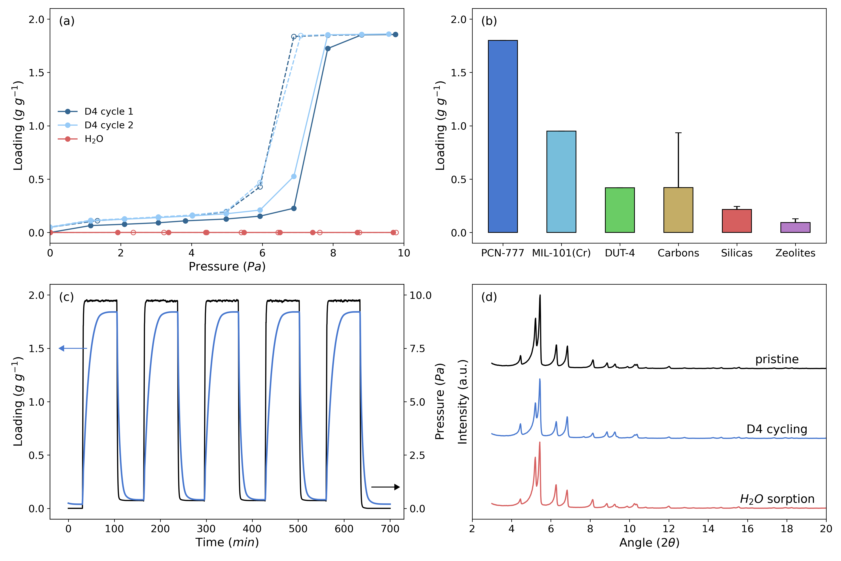

Figure 3: (a) Single component adsorption/desorption isotherms for D4 (blue) and $H2O$ (red) collected at 303 K for PCN-777 in the pressure range of 0-10 Pa (corresponding to 0–0.05 p/p0 for D4). Solid and open symbols represent adsorption and desorption branches, respectively. (b) Comparison of the D4 capacity of MOFs investigated in the present study with other classes of porous materials (data from [4]), with error bars placed at one standard deviation of mean capacity. (c) 5 D4 sorption-desorption cycles recorded after the first two isotherms on PCN-777, in the same pressure range. (d) PXRD of pristine PCN-777 (black) and samples recovered after D4 cycling (blue) and water adsorption (red).

## Experimental assessment of the D4 sorption performance for the top MOF

While HTCS enabled a rapid and effective screening on the performance indicator, additional criteria, such as thermal/chemical stability, synthesis route, activation conditions, precursor toxicity and linker availability need to be considered to select the optimal adsorbents. We therefore critically assessed PCN-777 prior to further experimental action. Our selection criteria for PCN-777 were (i) the excellent known stability of the oxo-Zr-carboxylate metal node, at the origin of the high chemical and thermal resistance of the framework, alongside with (ii) the commercially available linker and well-controlled synthesis procedure documented elsewhere [41], [54]. Indeed, this material was synthesised accordingly (details provided in the methodology section).

The D4 adsorption isotherm for PCN-777 was first recorded up to 10 Pa at 303 K using a dynamic vapour sorption system (experimental details in the methodology section). The resulting isotherm, depicted in fig. 3a, exhibits a characteristic type V shape [55] with a sharp D4 uptake increase above 7 Pa up to a maximum of 1.8 g/g that translates into 0.49 g/cm3. This value is however lower than the predicted uptake due to two combined reasons: (i) an incomplete evacuation of the porosity (theoretical PV=3.3 cm3/g vs the experimental one of 2.2 cm3/g determined through $N2$ physisorption at 77 K, in fig. 12, SI) commonly observed for mesoporous MOFs [56], [57] and (ii) only a partial accessibility of the super-tetrahedral cages to D4 owing to their relatively small windows. Indeed, while optimized synthesis and activation procedures may recover more of the expected porosity, the attained D4 uptake constitutes a record among porous solids. This positions PCN-777 as the porous material with the highest currently known D4 uptake, almost twice higher than the benchmark MIL-101(Cr), 5–10 times that of the most promising silicas and zeolites, and above the best performing activated carbons as illustrated in fig. 3b [4]. Notably, the step-like adsorption behaviour is ideal from the application point of view of a breakthrough filter, as it ensures a narrow mass transfer zone and minimises the column dead zone at break point. Remarkably, the maximum uptake for PCN-777 is attained at low pressure of 7 Pa that makes this MOF highly promising for D4 removal in a gas phase concentration below 75 ppm.

Throughout desorption (dotted line with open symbols in fig. 3a), a small hysteresis occurs with a width of about 1 Pa. Under complete vacuum, a minute amount of D4, about 0.1 g/g, i.e. 5% of total capacity, is retained in the structure. We attribute this capacity loss to D4 molecules irreversibly trapped in the super-tetrahedral cages or on a small fraction of defect sites. Overall, PCN-777 acts as a highly reversible D4-adsorbent. A second sorption cycle reveals the excellent repeatability of D4 sorption by this MOF, with identical condensation pressure and total uptake, the adsorption-desorption branches now overlapping in the very low-pressure region (fig. 3a).

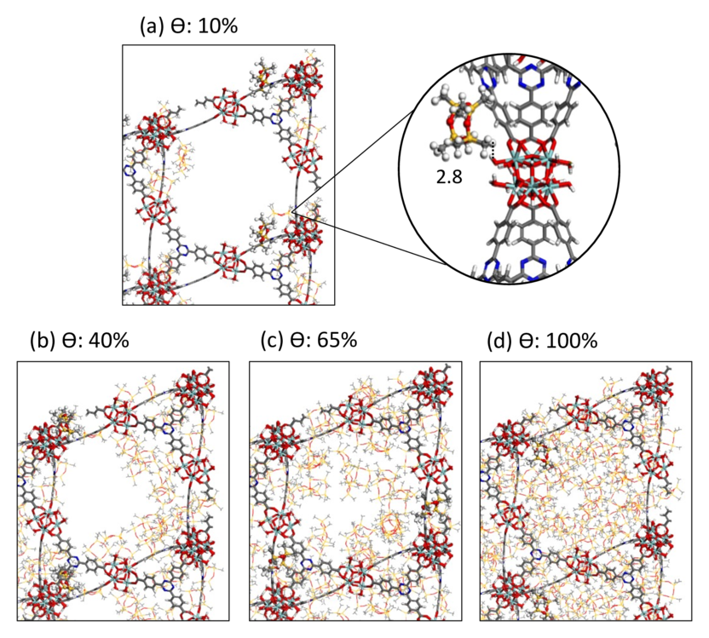

Figure 4: Representative snapshots of the preferential sitting of D4 in the pores of PCN-777 at 298 K for increasing loading at (a) 10% with highlighted interactions distance between D4 and the MOF framework, and at (b) 40%, (c) 65%, and (d) 100% fractional loading ($θ$). Framework atoms (sticks) and D4 molecules (lines, and ball and sticks) are coded as Zr, N, O, Si, C, and H atoms in light blue, dark blue, red, yellow, dark grey, and light grey respectively. The separating distance is represented by dashed black lines and reported in Å.

To further investigate the D4 adsorption-desorption cyclability of PCN-777, a subsequent set of five cycles was recorded on the same sample, covering the entire uptake range from fully loaded to empty under a medium vacuum level of 0.5 Pa (see fig. 3c). No further capacity loss is observed after the initial 5 wt% from cycle 1 to cycle 2 with a pressure drop sufficient to fully remove adsorbed D4 in every cycle without the need of thermal treatment. This is a leap forward compared to the previous MOF candidates, i.e. MIL-101(Cr) and DUT-4. The former was reported [22] to be fully regenerable at only high temperatures (outgassed under vacuum at 423 K), and we note that vacuum alone was unable to fully desorb D4, with nearly 50% of siloxane remaining in the structure after desorption in our experiments (fig. 14, SI). D4 adsorption in DUT-4 is even more irreversible, owing to the strong confinement of the siloxane molecules in its pores [21], with essentially no desorption observed under vacuum (fig. 14, SI). The global sorption kinetics was further qualitatively evaluated by observing the equilibration time throughout cycling steps. fig. 3c reveals that an adsorption/desorption cycle can be achieved in less than 30 minutes. Such a fast kinetics is a clear advantage for practical use. In addition, the water adsorption collected for PCN-777 further confirmed its predicted hydrophobicity and revealed that below $P=$7 Pa, water loading is negligible, i.e. under 0.02 g/g (see fig. 3a). This observation strongly suggests that PCN-777 is expected to maintain its high-level performance for D4 removal under low to moderate humidity working conditions.

Finally, stability of PCN-777 after its use as a D4 adsorbent was evaluated by checking its crystallinity and porosity. PXRD patterns recorded after the D4 cycling experiments show similar Bragg peak positions and broadenings as the pristine material, testifying that no amorphisation or decrease of crystallinity were incurred (fig. 3d). The same conclusion holds true for PCN-777 upon water adsorption. Further, $N2$ adsorption isotherms collected at 77 K for PCN-777 after $H2O$ and D4 adsorption both present a similar shape than that of the pristine solid (see fig. 12) while slightly lower pore volume (1.87 cm3/g vs 2.20 cm3/g) and BET area (1544 m2/g vs 1730 m2/g) were obtained for the material after D4 cycling, attributed to the small amount of D4 retained in the porous framework during the first adsorption cycle.

## Adsorption mechanism

A careful analysis of the adsorption mechanism of D4 in PCN-777 was further explored by considering MC simulations in the canonical ensemble with increasing loading up to the saturation (see methodology section for computational details). At the initial stage of adsorption, the coordinated OH/ $H2O$ moieties of the MOF $Zr6O4$ polyhedra pointing towards the pore were found to act as primary adsorption sites (fig. 4a). The D4 molecule interacts mostly via its methyl group with an averaged separating $H(CH3)−H(H2O)$ distance of 2.8 Å (see the radial distribution function plotted for the corresponding pair in fig. 9a) as illustrated in fig. 4a. This preferential sitting of D4 is associated with a moderately high simulated adsorption enthalpy of 83.5 kJ/mol in line with the isosteric heat of adsorption we assessed experimentally that ranges from 65 and 75 kJ/mol (fig. 15). Both values are slightly higher than the enthalpy of liquefaction of D4 at 303 K as 54.5 kJ/mol [46]. We further demonstrated that this value remains substantially lower than the one simulated for DUT-4 (194.0 kJ/mol) for which the adsorption of D4 is governed by a high degree of confinement leading to an irreversible process. This observation clearly states that the adsorption energetics in PCN-777 offers a good compromise to ensure an efficient adsorption of D4 as well as an almost fully reversible and fast adsorption/desorption process. While increasing the loading, D4 molecules tend to form a monolayer near the wall of the cage owing to their interactions with both the organic linkers and inorganic nodes of the MOF as shown in fig. 4b-c. Finally, at higher loading, the molecules form multilayers and further occupy the whole cage corresponding to the scenario of the capillary condensation (fig. 4d). This effective packing is governed by guest-guest interactions involving averaged separating $H(CH3)−H(CH3)$ distance of 2.7 Å at saturation (the radial distribution function plotted for this pair is shown in fig. 9b). Such pore filling mechanism has been commonly observed in diverse mesoporous materials for a range of molecules [58]. Indeed, PCN-777 exhibits an ideal combination of a large cage to enable an effective packing of the siloxane molecules and the presence of moieties accessible to D4 to favour host/guest interactions strong enough to ensure an efficient trapping of the D4 molecules initially adsorbed.

# Conclusions

In this work, a high throughput computational screening first identified a series of hydrophobic MOFs with octamethylcyclotetrasiloxane uptakes outperforming by far the performance of the conventional adsorbents. The best-predicted MOF performer, PCN-777, was synthesized and its predicted exceptional adsorption capacity for this typical contaminant present in biogas was further experimentally confirmed. This stable MOF was demonstrated to exhibit record gravimetric (1.8 g/g) and volumetric (0.49 g/cm3) uptake alongside with a reversible and fast adsorption/desorption process, very good cyclability and easy regeneration under continuous pressure cycling owing to a step-like sorption isotherm. The attractiveness of PCN-777 was found to result from a synergistic combination of mesoporous cages and chemical functionality pointing towards the center of the cages to ensure moderately high host/guest interactions and favour an efficient removal of D4 at low pressure and an efficient packing of the siloxane molecules at higher pressure while maintaining the process highly reversible. Moreover, its hydrophobicity makes this MOF promising for the selective removal of siloxanes in moderate humidity conditions. In a broader sense, this study highlights the efficacy of an integrated workflow for accelerating the selection of adsorbents for a target application, spanning the entire pipeline from method validation to computational screening, synthesis, adsorption testing and finally identification of the optimal candidates.

# Acknowledgements

We thank Centre National d’Etudes Spatiales for research funding (R&T n° R-S20/MT-0002-03 and PhD). PXRD experiments were performed with the support of the Balard Plateforme d’Analyses et de Caractérisation (PAC Balard).

# Author contributions

There are no conflicts of interest to declare.

# Supplementary Information

## Computational details

### Force field parameters for D4

D4 was modelled as a semi-flexible molecule with an all atom atomistic model. All intramolecular bonds, angles, dihedrals, and cross terms parameters for methyl groups were taken from the consistent-valence force field (CVFF). [38]

**Harmonic Bond**

$$U=\frac{1}{2}p_{0}{(r−p_{1})}^{2} (1)$$

where $p_{0}/κ_{B}$ in units K/Å², $p_{1}$ in Å.

Table 2: D4 bonding potential parameters.

|  |  |  |  |
| --- | --- | --- | --- |
| Pseudo atom | Type of bond | $p_{0}/κ_{B}$ (K/Å²) | $p_{1}$ (Å) |
| Si-O | RIGID_BOND | - | - |
| Si-C | HARMONIC_BOND | 286248.126 | 1.809 |
| C3-H | HARMONIC_BOND | 409668.576 | 1.105 |

**Harmonic Bend**

$$U=\frac{1}{2}p_{0}{(θ_{\text{ijk}}−p_{1})}^{2} (2)$$

where $p_{0}/κ_{B}$ in units K/rad², $p_{1}$ in degree.

Table 3: D4 bending potential parameters.

|  |  |  |  |
| --- | --- | --- | --- |
| Pseudo atom | Type of angle | $p_{0}/κ_{B}$ (K/rad²) | $p_{1}$ (°) |
| Si-C-H | HARMONIC_BEND | 41614.223 | 112.3 |
| C-Si-C | HARMONIC_BEND | 53400.911 | 113.5 |
| C-Si-O | HARMONIC_BEND | 53040.094 | 117.3 |
| H-C-H | HARMONIC_BEND | 47507.567 | 106.4 |

**CVFF Dihedral**

$$U=p_{0}{(1+cos(p_{1}ϕ_{\text{ijk}}−p_{2}))}^{2} (3)$$

where $p_{0}/κ_{B}$ in units K, $p_{2}$ in degree.

Table 4: D4 dihedral potential parameters.

|  |  |  |  |  |
| --- | --- | --- | --- | --- |
| Pseudo atom | Type of torsion | $p_{0}/κ_{B}$ (K) | $p_{1}$ (multiplicity) | $p_{2}$ (°) |
| H-C-Si-C | CVFF_DIHEDRAL | 240.545 | 3 | 0 |
| H-C-Si-O | CVFF_DIHEDRAL | -60.136 | 3 | 0 |
| C-Si-O-Si | CVFF_DIHEDRAL | 240.545 | 3 | 0 |

**CFF Bond Bond Cross**

$$U=p_{0}(r−p_{1})(r′−p_{2}) (4)$$

where $p_{0}/κ_{B}$ in units K/Å², $p_{1}$ and $p_{2}$ in Å

Table 5: D4 cross-term bonding potential parameters.

|  |  |  |  |  |
| --- | --- | --- | --- | --- |
| Pseudo atom | Type of bond-bond | $p_{0}/κ_{B}$ (K/Å²) | $p_{1}$ (Å) | $p_{2}$ (Å) |
| Si-C-H | CFF_BOND_BOND_CROSS | 14312.406 | 0 | 0 |
| C-Si-C | CFF_BOND_BOND_CROSS | 7336.612 | 0 | 0 |
| C-Si-O | CFF_BOND_BOND_CROSS | 25257.188 | 0 | 0 |

**CFF Bond Bend Cross**

$$U={(θ−p}_{0})[p_{1}(r−p_{2})+p_{3}(r′−p_{4})] (5)$$

where $p_{0}$ in degrees, $p_{1}$ and $p_{3}$ in units K/Å/rad, $p_{1}$ and $p_{2}$ in Å.

Table 6: D4 cross-term bonding-bending potential parameters.

|  |  |  |  |  |  |  |
| --- | --- | --- | --- | --- | --- | --- |
| Pseudo atom | Type of bond-angle | po (°) | $p_{1}$ (K/Å/rad) | $p_{2}$ (Å) | $p_{3}$ (K/Å/rad) | $p_{4}$ (Å) |
| Si-C-H | CFF_BOND_BEND_CROSS | 0 | 14733.359 | 0 | 9742.06 | 0 |
| C-Si-C | CFF_BOND_BEND_CROSS | 0 | 781.770 | 0 | 0 | 0 |
| C-Si-O | CFF_BOND_BEND_CROSS | 0 | 11425.871 | 0 | 27061.27 | 0 |

**D4 LJ parameters and charges**

The electronic potential (ESP) derived partial charges of D4 were computed by density functional theory (DFT) calculations with PBE (Perdew-Burke-Ernzerhof) functional [59] and DNP (double numeric plus polarization) basis set [60], using DMol3 module [61] in Materials Studio [62] (tbl. 7).

Table 7: Charges and Lennard-Jones parameters for all atoms of D4.

|  |  |  |  |
| --- | --- | --- | --- |
| Pseudo atom | Charge (e-) | (K) | $σ$ (Å) |
| Si | 1.321 | 202.429 | 3.826 |
| O | -0.763 | 30.213 | 3.118 |
| C | -0.889 | 52.873 | 3.431 |
| H | 0.2032 | 22.156 | 2.571 |

### Screening dataset

1710 non-disordered MOFs with pore limiting diameters > 6 Å were screened from CoRE-MOF database, to which 29 well-known MOFs were added with proven stability and high porosity, including the MOF-74 isoreticular series [63], Cr-soc-MOF-1 [64], UiO-68 (UiO for University of Oslo), MOF-808, [65] and a several structures originating from Dresden University of Technology (DUT) and Material of Institute Lavoisier (MIL). This additional list is given in tbl. 8.

The combined dataset of 1739 MOFs show a broad range of geometric and textural features: PLDs (6.0–71.5 Å), $N2$ accessible SA (320–6770 m2/g), density (0.13–2.22 g/cm3), (0.42–0.94) and PVs (0.23–7.46 cm3/g).

Table 8: Details of the 29 MOFs added to the COREMOF database.

|  |  |  |  |
| --- | --- | --- | --- |
| MOFs | Reference | MOFs | Reference |
| RAVWAO | [63] | DUT-5 | [66] |
| RAVWES | [63] | DUT-51-Zr | [67] |
| RAVWIW | [63] | DUT-67-Zr | [68] |
| RAVWOC | [63] | MIL-68(Al) | [69] |
| RAVWUI | [63] | Cr-soc-MOF-1 | [64] |
| RAVXAP | [63] | MIP[4]-177 | [70] |
| RAVXET | [63] | MIP-200 | [71] |
| RAVXIX | [63] | Zr-IPA[5] | [72] |
| MIL-125 | [65] | Ni-BPM[6] | [73] |
| MOF-808-acetate | [65] | Ni-BPP[7] | [73] |
| MOF-808-formate | [65] | Ni-TPM[8] | [73] |
| NU[1]-1000 | [65] | Ni-TPP[9] | [73] |
| UiO[2]-68 | [65] | Ni-MOF-74 | [73] |
| Zr6-AzoBDC[3] | [65] | PCN[10]-224(Ni) | [74] |
| [1]NU: Northwestern University; [2]UiO: University of Oslo; |  |  |  |
| [3]AzoBDC: azobenzenedicarboxylate; |  |  |  |
| [4]MIP: material of the Institute of Porous Materials from Paris; |  |  |  |
| [5]IPA: isophatale; [6]BPM: biphenyl-meta; |  |  |  |
| [7]BPP: biphenyl-para; [8]TPM: triphenyl-meta; |  |  |  |
| [9]TPP: triphenyl-para; [10]PCN: Porous coordination network; |  |  |  |

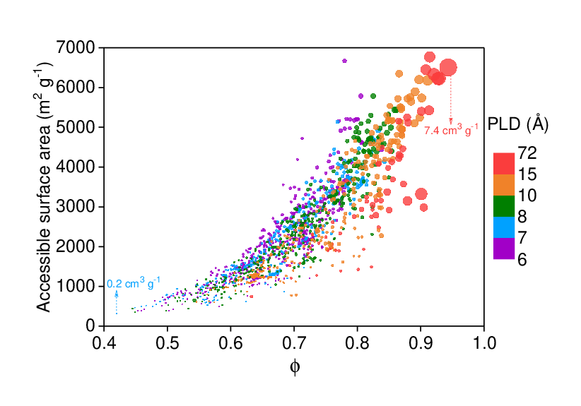

Figure 5: Overview of the diversity of the MOF database with PLD > 6 Å in terms of void fractions, accessible surface areas and PLDs. Data points are color coded by PLDs of MOFs. Pore volumes of all structures are represented by size.

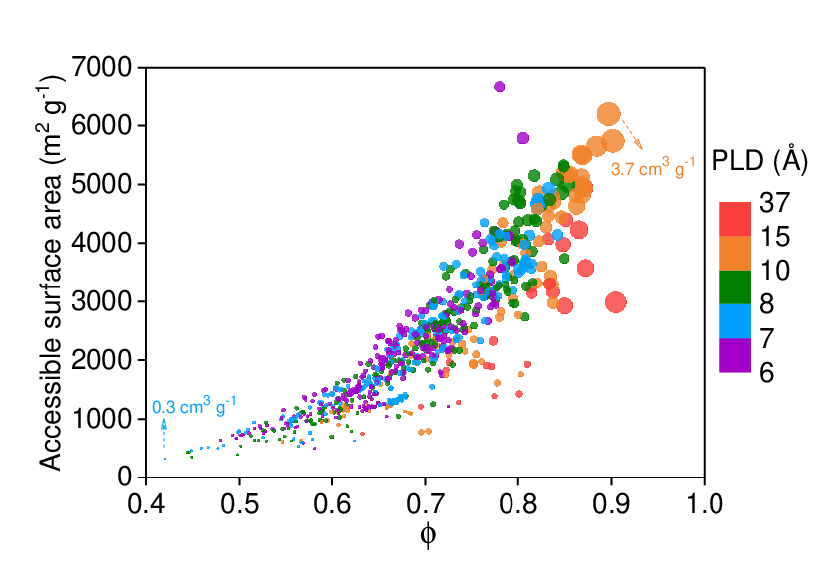

Figure 6: Overview of the diversity of the hydrophobic MOFs database in terms of void fraction and accessible surface areas. Data points are color coded by PLDs of MOFs. Pore volumes of all structures are represented by size.

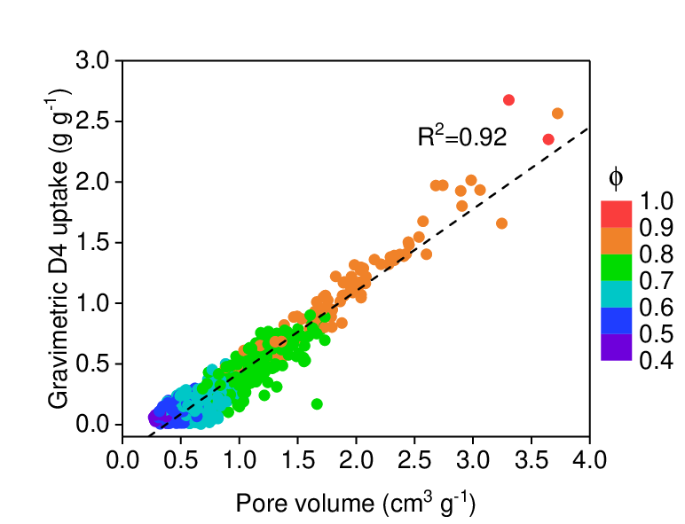

Figure 7: The relation of gravimetric D4 uptake of the 811 hydrophobic MOFs (g g-1) and their pore volumes (cm3 g-1), color coded by void fraction of the MOFs.

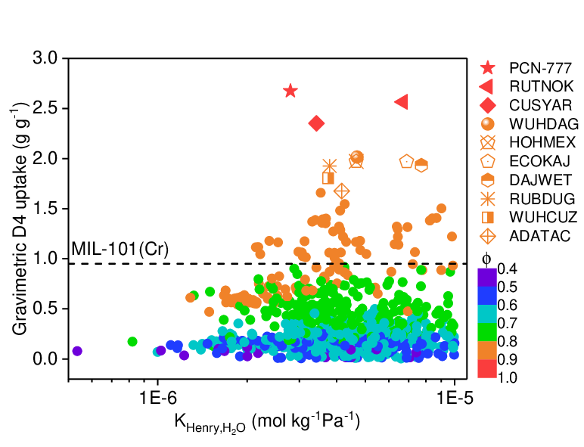

Figure 8: Predicted D4 uptake performance at 298 K for the hydrophobic MOFs database plotted as a function of their computed Henry constant for water, color coded by void fraction, $ϕ$. Top performing 10 candidates are represented by different symbols in the legend to the right.

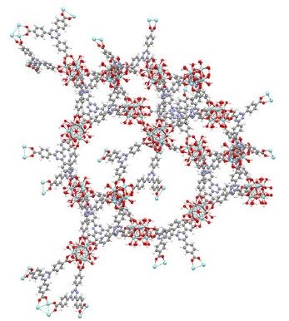  
**Metal site:** Zr  
**PLD:** 28.36 Å  
**SA:** 2990 m2/g  
**Density:** 0.27 g/cm3  
**PV:** 3.31 cm3/g  
**:** 0.90  
**Gravimetric D4 uptake:** 2.68 g/g  
**Volumetric D4 uptake:** 0.72 g/cm3

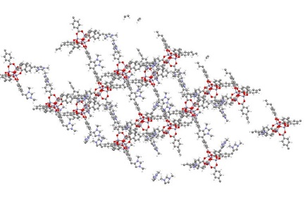  
4,7-bis(4-carboxylphenyl)-1,3-dimethylbenzimidazium-tetrafluoroborate  
**Metal site:** Zn  
**PLD:** 14.65 Å  
**SA:** 6200 m2/g  
**Density:** 0.24 g/cm3  
**PV:** 3.72 cm3/g  
**:** 0.90  
**Gravimetric D4 uptake:** 2.57 g/g  
**Volumetric D4 uptake:** 0.62 g/cm3

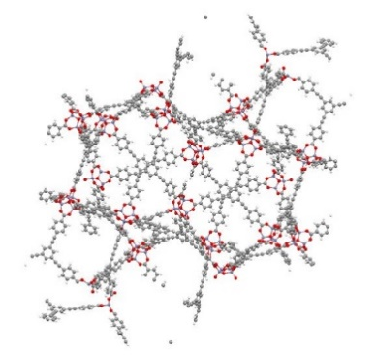  
**Metal site:** Zn  
**PLD:** 12.18 Å  
**SA:** 5700 m2/g  
**Density:** 0.25 g/cm3  
**PV:** 3.65 cm3/g  
**:** 0.90  
**Gravimetric D4 uptake:** 2.35 g/g  
**Volumetric D4 uptake:** 0.59 g/cm3

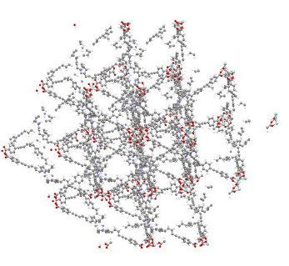  
**Metal site:** Zr  
**PLD:** 10.50 Å  
**SA:** 5500 m2/g  
**Density:** 0.29 g/cm3  
**PV:** 2.99 cm3/g  
**:** 0.87  
**Gravimetric D4 uptake:** 2.01 g/g  
**Volumetric D4 uptake:** 0.58 g/cm3

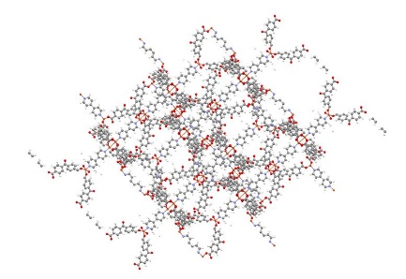  
**Metal site:** Cu  
**PLD:** 14.89 Å  
**SA:** 5000 m2/g  
**Density:** 0.32 g/cm3  
**PV:** 2.74 cm3/g  
**:** 0.87  
**Gravimetric D4 uptake:** 1.97 g/g  
**Volumetric D4 uptake:** 0.63 g/cm3

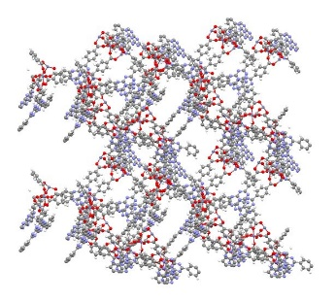  
**Metal site:** Zn  
**PLD:** 17.58 Å  
**SA:** 3600 m2/g  
**Density:** 0.33 g/cm3  
**PV:** 2.68 cm3/g  
**:** 0.87  
**Gravimetric D4 uptake:** 1.97 g/g  
**Volumetric D4 uptake:** 0.65 g/cm3

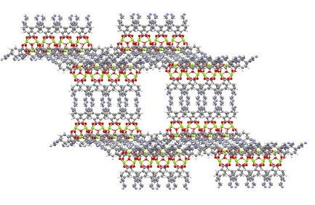  
**Metal site:** Mg  
**PLD:** 26.59 Å  
**SA:** 5000 m2/g  
**Density:** 0.28 g/cm3  
**PV:** 3.06 cm3/g  
**:** 0.87  
**Gravimetric D4 uptake:** 1.93 g/g  
**Volumetric D4 uptake:** 0.54 g/cm3

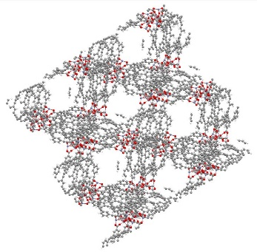  
**Metal site:** Zn  
**PLD:** 19.25 Å  
**SA:** 4200 m2/g  
**Density:** 0.30 g/cm3  
**PV:** 2.90 cm3/g  
**:** 0.87  
**Gravimetric D4 uptake:** 1.93 g/g  
**Volumetric D4 uptake:** 0.58 g/cm3

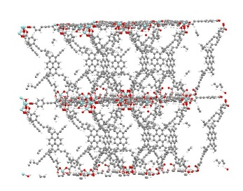  
4,4’,4“,4”’-((pyrene-1,3,6,8 tetrayltetrakis(benzene-4,1-diyl)) tetrakis(ethyne-2,1 diyl))tetrabenzoate  
**Metal site:** Zr  
**PLD:** 12.21 Å  
**SA:** 5500 m2/g  
**Density:** 0.30 g/cm3  
**PV:** 2.91 cm3/g  
**:** 0.87  
**Gravimetric D4 uptake:** 1.80 g/g  
**Volumetric D4 uptake:** 0.54 g/cm3

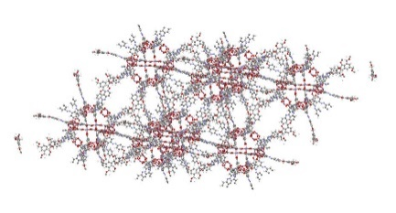  
5,5’,5“-(4,4’,4”-[1,3,5-phenyltris(methoxy)] tris-phenylazo) tris-isophthalic acid  
**Metal site:** Zn  
**PLD:** 10.28 Å  
**SA:** 5130 m2/g  
**Density:** 0.34 g/cm3  
**PV:** 2.57 cm3/g  
**:** 0.87  
**Gravimetric D4 uptake:** 1.68 g/g  
**Volumetric D4 uptake:** 0.57 g/cm3  
——————————————————————————————————— –

: Structural details of the top promising 10 hydrophobic materials which exhibit the highest D4 uptake.

### Radial distribution functions for D4-PCN-777

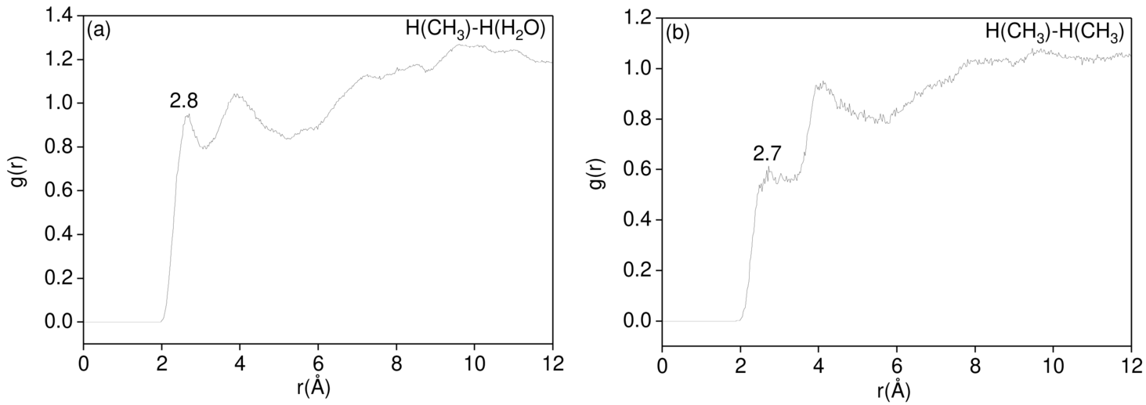

Figure 9: All-atom averaged radial distribution functions between (a) H atom from $CH3$ group of D4 molecules and H atom from coordinated water of the framework at 10% total loading and (b) H atom from $CH3$ groups of D4 at 100% loading.

## MOF samples

### MIL-101(Cr)

The benchmark MIL-101(Cr) sample was taken from a previous work [40], with all textural characteristics as stated in reference.

### DUT-4

DUT-4 was purchased from Materials Center (TU Dresden, Germany).

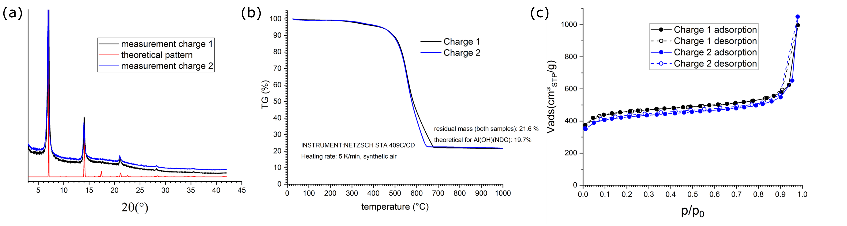

Figure 10: Characterization of the DUT-4 sample, in duplicates as black and blue: (a) PXRD, alongside simulated pattern in red (b) TGA curves and (c) $N2$ physisorption isotherms at 77 K.

### PCN-777

**Synthesis**

To synthesize the PCN-777, $ZrOCl2*8H2O$ (1.08 g, 3.351 mmol) and 4,4’,4’’-s-Triazine-2,4,6-triyl-tribenzoic acid (0.270 g, 0.612 mmol) were put into 36 ml N,N-Diethylformamide (DEF) in a 100 ml Teflon-lined autoclave reactor, alongside an amount of trifluoroacetic acid (1.8 ml) to form a reaction solution. After sonicating the reaction solution at room temperature for 10 min, the reactor was transferred to a convection oven followed by heating at 423 K for 12 h. The PCN-777 crystalline solid was recovered by filtration after purification with 100 ml N,N-Dimethylformamide (DMF) and acetone for 3 h at room temperature. The collected crystalline solid was dried at 393 K for 12 h.

**Characterisation**

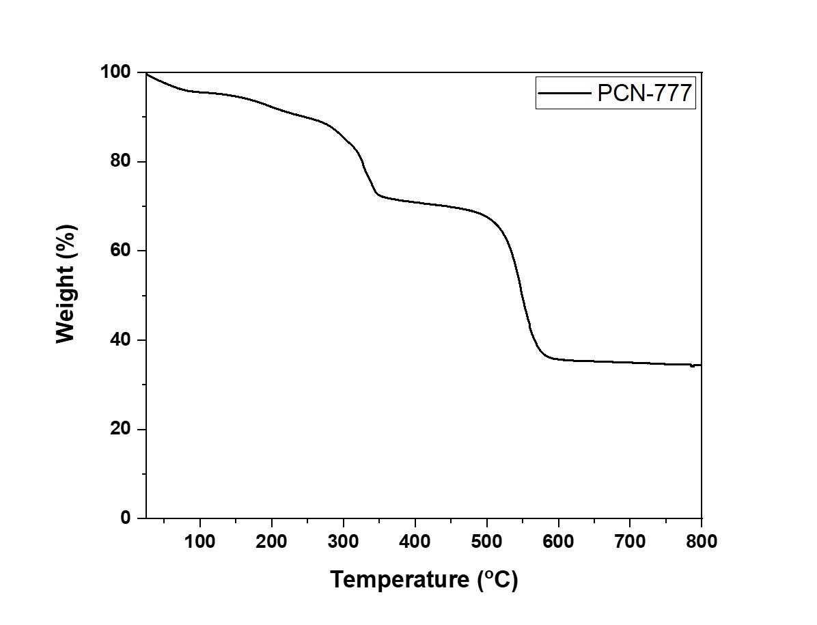

Figure 11: Thermogravimetric curve recorded on as-synthesised PCN-777.

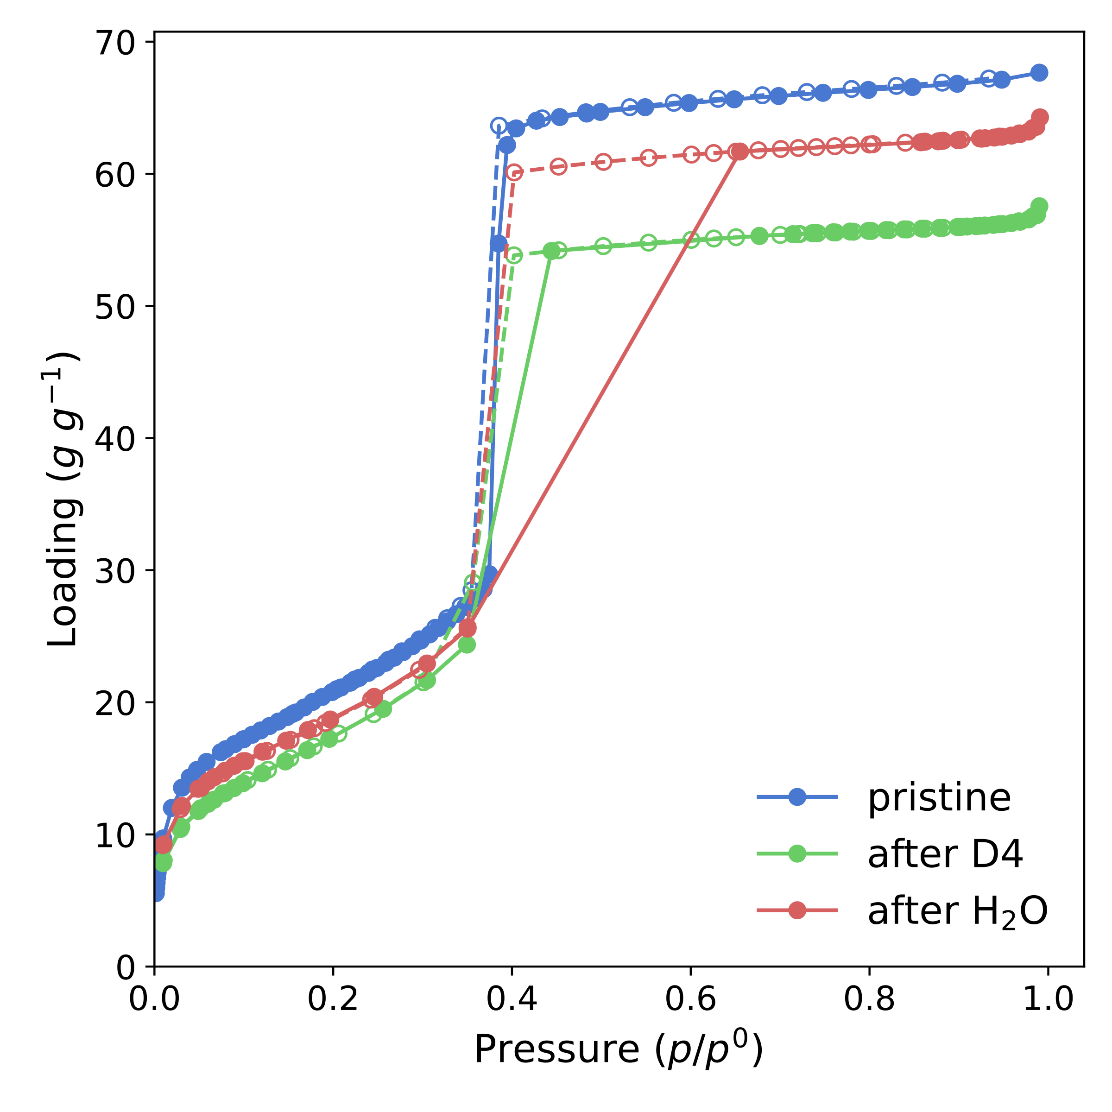

Figure 12: Nitrogen sorption isotherms at 77 K for the pristine PCN-777, alongside those measured on samples after D4 and water sorption.

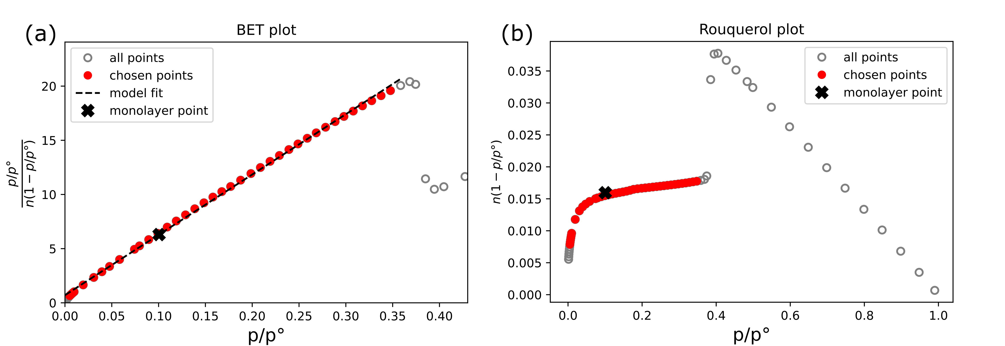

Figure 13: BET and Rouquerol plots displaying selection of applicable isotherm points for the pristine PCN-777 isotherm.

## D4 sorption experiments

### D4 benchmarking with known MOFs

Isotherms were recorded on benchmark materials MIL-101(Cr) and DUT-4 using the same methodology detailed in the main manuscript.

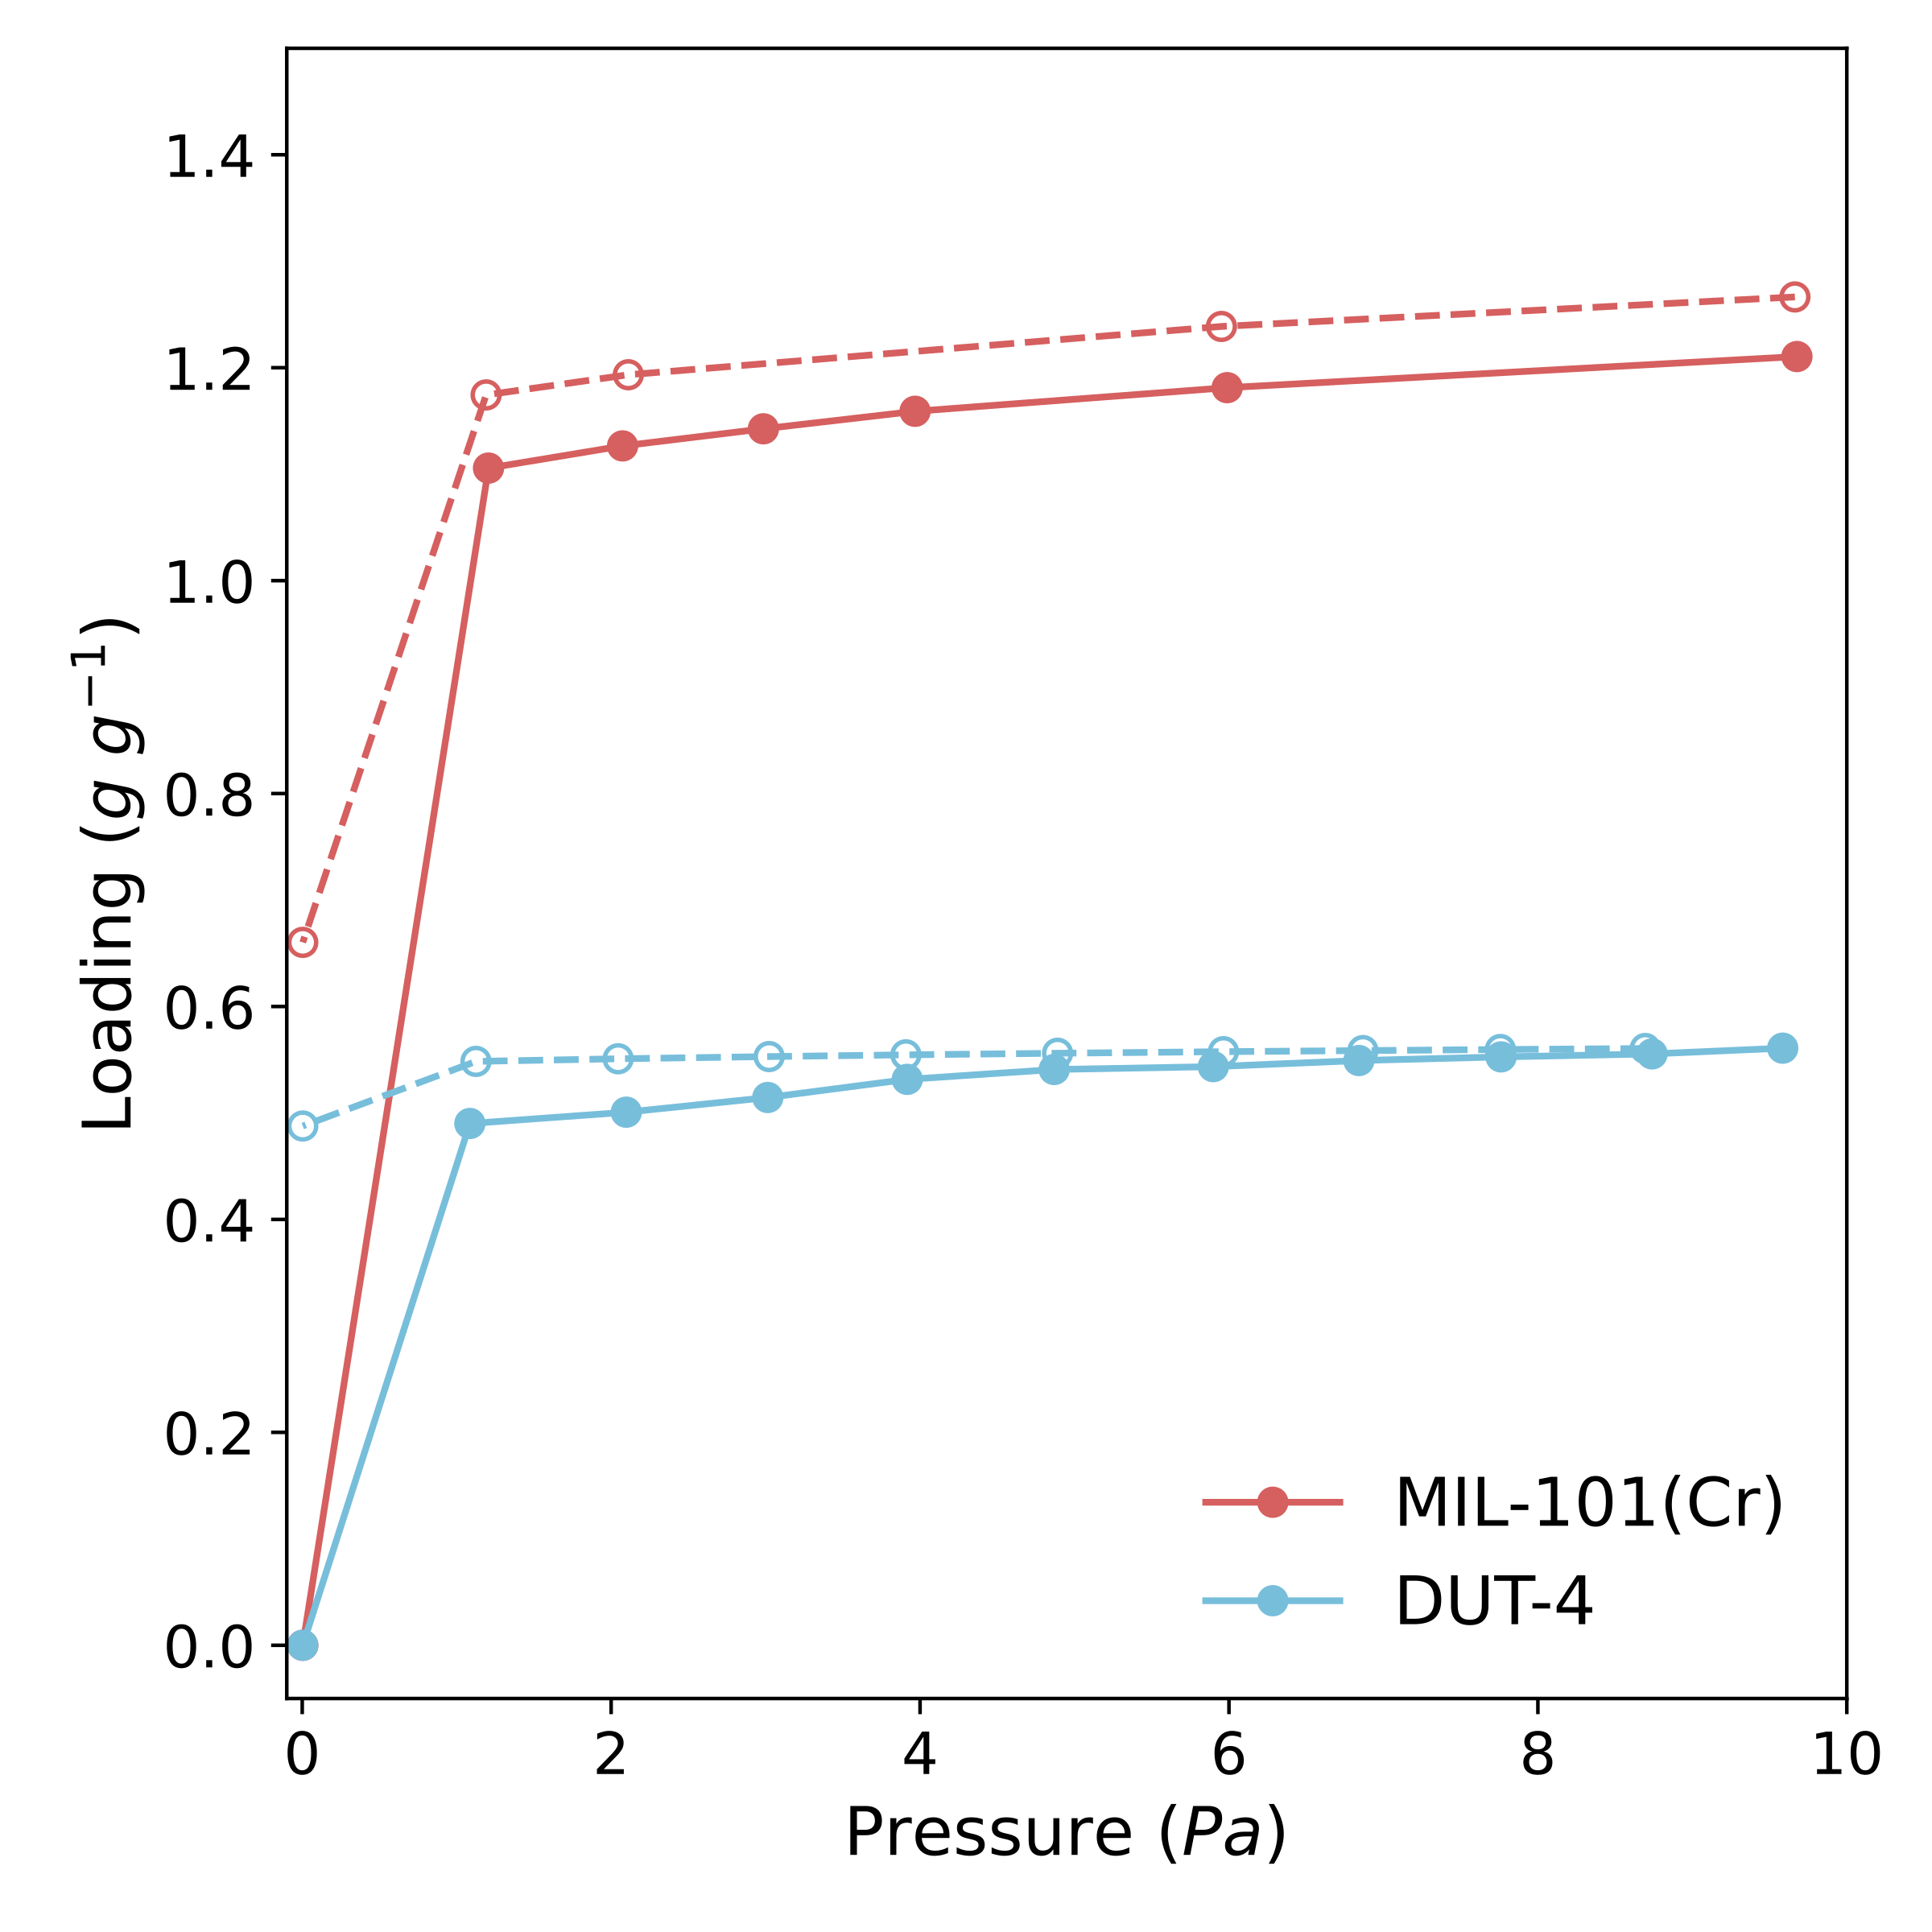

Figure 14: D4 isotherms recorded on samples of MIL-101(Cr) (red) and DUT-4 (blue), used to validate our computational methodology for predicting total D4 capacity. Note the different desorption behavior (open symbols) of the two materials under secondary vacuum: partial desorption for MIL-101(Cr) and no desorption for DUT-4.

### Isosteric heat of sorption of D4

A further isotherm was recorded at 313 K (40 °C) to allow for the calculation of the isosteric heat of adsorption through the Clausius-Clapeyron equation, as depicted in fig. 15.

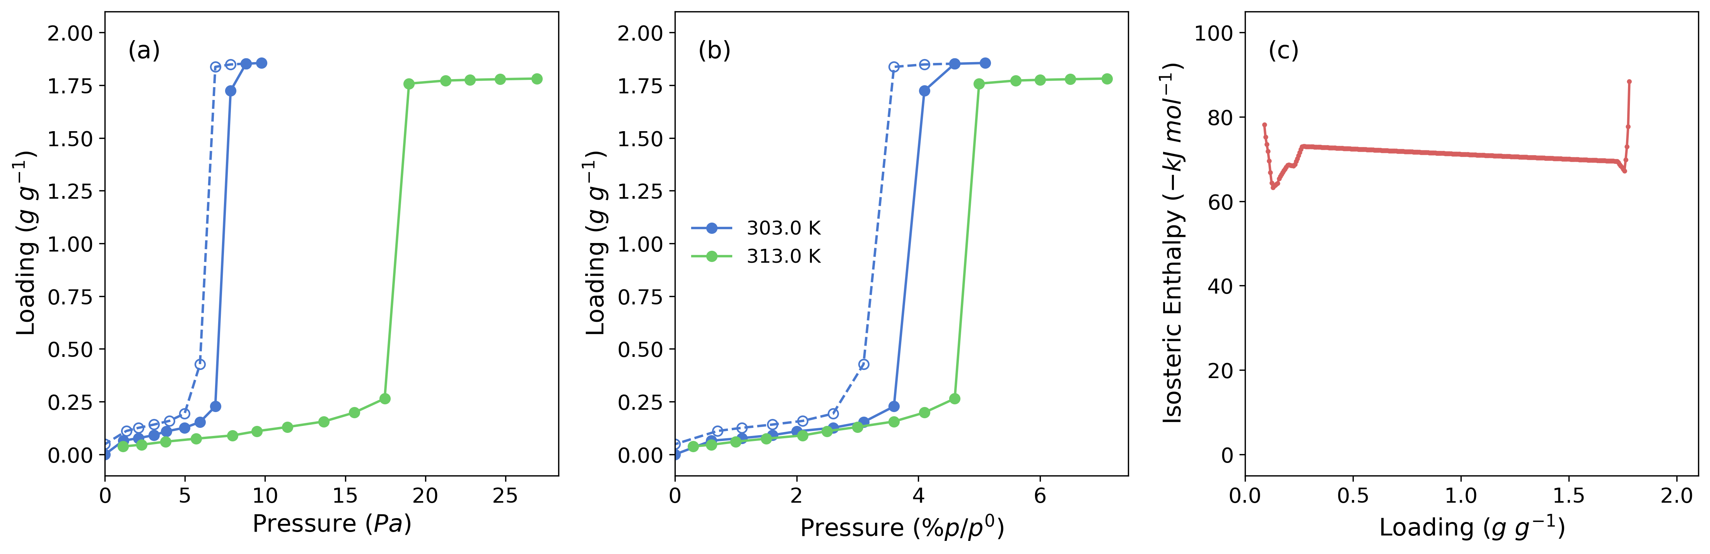

Figure 15: D4 sorption isotherms on PCN-777 recorded at 303 K (blue) and at 313 K (green) in an absolute (a) and relative (b) pressure scale. (c) The calculated isosteric heat of adsorption as a function of D4 uptake.

## References

[1] N. J. Themelis and P. A. Ulloa, “Methane generation in landfills,” *Renewable Energy*, vol. 32, no. 7, pp. 1243–1257, Jun. 2007, doi: [10.1016/j.renene.2006.04.020](https://doi.org/10.1016/j.renene.2006.04.020).

[2] Y. Takuwa, T. Matsumoto, K. Oshita, M. Takaoka, S. Morisawa, and N. Takeda, “Characterization of trace constituents in landfill gas and a comparison of sites in Asia,” *J Mater Cycles Waste Manag*, vol. 11, no. 4, pp. 305–311, Dec. 2009, doi: [10.1007/s10163-009-0257-1](https://doi.org/10.1007/s10163-009-0257-1).

[3] A. Ohannessian, V. Desjardin, V. Chatain, and P. Germain, “Volatile organic silicon compounds: The most undesirable contaminants in biogases,” *Water Science and Technology*, vol. 58, no. 9, pp. 1775–1781, Nov. 2008, doi: [10.2166/wst.2008.498](https://doi.org/10.2166/wst.2008.498).

[4] G. Wang, Z. Zhang, and Z. Hao, “Recent advances in technologies for the removal of volatile methylsiloxanes: A case in biogas purification process,” *Critical Reviews in Environmental Science and Technology*, vol. 49, no. 24, pp. 2257–2313, Dec. 2019, doi: [10.1080/10643389.2019.1607443](https://doi.org/10.1080/10643389.2019.1607443).

[5] R. Dewil, L. Appels, and J. Baeyens, “Energy use of biogas hampered by the presence of siloxanes,” *Energy Conversion and Management*, vol. 47, no. 13–14, pp. 1711–1722, Aug. 2006, doi: [10.1016/j.enconman.2005.10.016](https://doi.org/10.1016/j.enconman.2005.10.016).

[6] J. N. Kuhn, A. C. Elwell, N. H. Elsayed, and B. Joseph, “Requirements, techniques, and costs for contaminant removal from landfill gas,” *Waste Management*, vol. 63, pp. 246–256, May 2017, doi: [10.1016/j.wasman.2017.02.001](https://doi.org/10.1016/j.wasman.2017.02.001).

[7] K. F. Chin *et al.*, “Statistical analysis of trace contaminants measured in biogas,” *Sci. Total Environ.*, vol. 729, p. 138702, 2020.

[8] M. Ajhar, M. Travesset, S. Yüce, and T. Melin, “Siloxane removal from landfill and digester gas - a technology overview,” *Bioresour. Technol.*, vol. 101, no. 9, pp. 2913–2923, 2010.

[9] E. Finocchio, G. Garuti, M. Baldi, and G. Busca, “Decomposition of hexamethylcyclotrisiloxane over solid oxides,” *Chemosphere*, vol. 72, no. 11, pp. 1659–1663, 2008.

[10] T. Montanari *et al.*, “Purification of landfill biogases from siloxanes by adsorption: A study of silica and 13X zeolite adsorbents on hexamethylcyclotrisiloxane separation,” *Chemical Engineering Journal*, vol. 165, no. 3, pp. 859–863, Dec. 2010, doi: [10.1016/j.cej.2010.10.032](https://doi.org/10.1016/j.cej.2010.10.032).

[11] L. Sigot, G. Ducom, and P. Germain, “Adsorption of octamethylcyclotetrasiloxane (D4) on silica gel (SG): Retention mechanism,” *Microporous and Mesoporous Materials*, vol. 213, pp. 118–124, Sep. 2015, doi: [10.1016/j.micromeso.2015.04.016](https://doi.org/10.1016/j.micromeso.2015.04.016).

[12] M. Schweigkofler and R. Niessner, “Removal of siloxanes in biogases,” *Journal of Hazardous Materials*, vol. 83, no. 3, pp. 183–196, May 2001, doi: [10.1016/S0304-3894(00)00318-6](https://doi.org/10.1016/S0304-3894(00)00318-6).

[13] G. Férey, “Hybrid porous solids: Past, present, future,” *Chem. Soc. Rev.*, vol. 37, no. 1, pp. 191–214, 2008, doi: [10.1039/B618320B](https://doi.org/10.1039/B618320B).

[14] H.-C. Zhou, J. R. Long, and O. M. Yaghi, “Introduction to MetalOrganic Frameworks,” *Chemical Reviews*, vol. 112, no. 2, pp. 673–674, Feb. 2012, doi: [10.1021/cr300014x](https://doi.org/10.1021/cr300014x).

[15] J. D. Evans, V. Bon, I. Senkovska, H.-C. Lee, and S. Kaskel, “Four-dimensional metal-organic frameworks,” *Nat Commun*, vol. 11, no. 1, p. 2690, Dec. 2020, doi: [10.1038/s41467-020-16527-8](https://doi.org/10.1038/s41467-020-16527-8).

[16] R. L. Siegelman, P. J. Milner, E. J. Kim, S. C. Weston, and J. R. Long, “Challenges and opportunities for adsorption-based CO 2 capture from natural gas combined cycle emissions,” *Energy Environ. Sci.*, vol. 12, no. 7, pp. 2161–2173, 2019, doi: [10.1039/C9EE00505F](https://doi.org/10.1039/C9EE00505F).

[17] R.-B. Lin, S. Xiang, W. Zhou, and B. Chen, “Microporous Metal-Organic Framework Materials for Gas Separation,” *Chem*, vol. 6, no. 2, pp. 337–363, Feb. 2020, doi: [10.1016/j.chempr.2019.10.012](https://doi.org/10.1016/j.chempr.2019.10.012).

[18] A. Bavykina, N. Kolobov, I. S. Khan, J. A. Bau, A. Ramirez, and J. Gascon, “MetalOrganic Frameworks in Heterogeneous Catalysis: Recent Progress, New Trends, and Future Perspectives,” *Chem. Rev.*, vol. 120, no. 16, pp. 8468–8535, Aug. 2020, doi: [10.1021/acs.chemrev.9b00685](https://doi.org/10.1021/acs.chemrev.9b00685).

[19] M. D. Allendorf, R. Dong, X. Feng, S. Kaskel, D. Matoga, and V. Stavila, “Electronic Devices Using Open Framework Materials,” *Chem. Rev.*, vol. 120, no. 16, pp. 8581–8640, Aug. 2020, doi: [10.1021/acs.chemrev.0c00033](https://doi.org/10.1021/acs.chemrev.0c00033).

[20] M. Woellner, S. Hausdorf, N. Klein, P. Mueller, M. W. Smith, and S. Kaskel, “Adsorption and Detection of Hazardous Trace Gases by Metal-Organic Frameworks,” *Adv. Mater.*, vol. 30, no. 37, p. 1704679, Sep. 2018, doi: [10.1002/adma.201704679](https://doi.org/10.1002/adma.201704679).

[21] Y. Mito-oka *et al.*, “Siloxane D4 capture by hydrophobic microporous materials,” *J. Mater. Chem. A*, vol. 1, no. 27, p. 7885, 2013, doi: [10.1039/c3ta11217a](https://doi.org/10.1039/c3ta11217a).

[22] N. Gargiulo *et al.*, “Chromium-based MIL-101 metal organic framework as a fully regenerable D4 adsorbent for biogas purification,” *Renewable Energy*, vol. 138, pp. 230–235, Aug. 2019, doi: [10.1016/j.renene.2019.01.096](https://doi.org/10.1016/j.renene.2019.01.096).

[23] H. Zhao, Q. Li, Z. Wang, T. Wu, and M. Zhang, “Synthesis of MIL-101(Cr) and its water adsorption performance,” *Microporous and Mesoporous Materials*, vol. 297, p. 110044, May 2020, doi: [10.1016/j.micromeso.2020.110044](https://doi.org/10.1016/j.micromeso.2020.110044).

[24] C. M. Simon, R. Mercado, S. K. Schnell, B. Smit, and M. Haranczyk, “What Are the Best Materials To Separate a Xenon/Krypton Mixture?” *Chem. Mater.*, vol. 27, no. 12, pp. 4459–4475, Jun. 2015, doi: [10.1021/acs.chemmater.5b01475](https://doi.org/10.1021/acs.chemmater.5b01475).

[25] J. Park, R. P. Lively, and D. S. Sholl, “Establishing upper bounds on CO2 swing capacity in sub-ambient pressure swing adsorption via molecular simulation of metalorganic frameworks,” *J. Mater. Chem. A*, vol. 5, no. 24, pp. 12258–12265, 2017, doi: [10.1039/C7TA02916K](https://doi.org/10.1039/C7TA02916K).

[26] P. Z. Moghadam *et al.*, “Computer-aided discovery of a metalorganic framework with superior oxygen uptake,” *Nat Commun*, vol. 9, no. 1, p. 1378, Dec. 2018, doi: [10.1038/s41467-018-03892-8](https://doi.org/10.1038/s41467-018-03892-8).

[27] P. G. Boyd *et al.*, “Data-driven design of metalorganic frameworks for wet flue gas CO2 capture,” *Nature*, vol. 576, no. 7786, pp. 253–256, Dec. 2019, doi: [10.1038/s41586-019-1798-7](https://doi.org/10.1038/s41586-019-1798-7).

[28] Z. Shi, H. Liang, W. Yang, J. Liu, Z. Liu, and Z. Qiao, “Machine learning and in silico discovery of metal-organic frameworks: Methanol as a working fluid in adsorption-driven heat pumps and chillers,” *Chemical Engineering Science*, vol. 214, p. 115430, Mar. 2020, doi: [10.1016/j.ces.2019.115430](https://doi.org/10.1016/j.ces.2019.115430).

[29] Z. Yao *et al.*, “Inverse design of nanoporous crystalline reticular materials with deep generative models,” *Nat Mach Intell*, Jan. 2021, doi: [10.1038/s42256-020-00271-1](https://doi.org/10.1038/s42256-020-00271-1).

[30] Y. G. Chung *et al.*, “Advances, updates, and analytics for the computation-ready, experimental MetalOrganic framework database: CoRE MOF 2019,” *J. Chem. Eng. Data*, vol. 64, no. 12, pp. 5985–5998, 2019.

[31] T. F. Willems, C. H. Rycroft, M. Kazi, J. C. Meza, and M. Haranczyk, “Algorithms and tools for high-throughput geometry-based analysis of crystalline porous materials,” *Microporous and Mesoporous Materials*, vol. 149, no. 1, pp. 134–141, Feb. 2012, doi: [10.1016/j.micromeso.2011.08.020](https://doi.org/10.1016/j.micromeso.2011.08.020).

[32] D. Dubbeldam, S. Calero, D. E. Ellis, and R. Q. Snurr, “RASPA: Molecular simulation software for adsorption and diffusion in flexible nanoporous materials,” *Mol. Simul.*, vol. 42, no. 2, pp. 81–101, 2016.

[33] D. Frenkel and B. Smit, *Understanding molecular simulation: From algorithms to applications*, vol. 1. Academic press: London, 2002.

[34] P. P. Ewald, “Die berechnung optischer und elektrostatischer gitterpotentiale,” *Ann. Phys.*, vol. 369, no. 3, pp. 253–287, 1921.

[35] Z. Qiao, Q. Xu, A. K. Cheetham, and J. Jiang, “High-throughput computational screening of metal-organic frameworks for thiol capture,” *J. Phys. Chem. C*, vol. 121, no. 40, pp. 22208–22215, 2017.

[36] S. Keskin, J. Liu, R. B. Rankin, J. K. Johnson, and D. S. Sholl, “Progress, Opportunities, and Challenges for Applying Atomically Detailed Modeling to Molecular Adsorption and Transport in Metal-Organic Framework Materials,” *Ind. Eng. Chem. Res.*, vol. 48, no. 5, pp. 2355–2371, Mar. 2009, doi: [10.1021/ie800666s](https://doi.org/10.1021/ie800666s).

[37] J. L. Abascal and C. Vega, “A general purpose model for the condensed phases of water: TIP4P/2005,” *J. Chem. Phys.*, vol. 123, no. 23, pp. 234505–234517, 2005.

[38] P. Dauber-Osguthorpe, V. A. Roberts, D. J. Osguthorpe, J. Wolff, M. Genest, and A. T. Hagler, “Structure and energetics of ligand binding to proteins: Escherichia coli dihydrofolate Reductase-Trimethoprim, a Drug-Receptor system,” *Proteins: Struct., Funct., Bioinf.*, vol. 4, no. 1, pp. 31–47, 1988.

[39] R.-G. Xu and Y. Leng, “Solvation force simulations in atomic force microscopy,” *The Journal of Chemical Physics*, vol. 140, no. 21, p. 214702, Jun. 2014, doi: [10.1063/1.4879657](https://doi.org/10.1063/1.4879657).

[40] R. S. Pillai *et al.*, “N 2 Capture Performances of the Hybrid Porous MIL-101(Cr): From Prediction toward Experimental Testing,” *J. Phys. Chem. C*, vol. 121, no. 40, pp. 22130–22138, Oct. 2017, doi: [10.1021/acs.jpcc.7b07029](https://doi.org/10.1021/acs.jpcc.7b07029).

[41] D. Feng *et al.*, “A Highly Stable Zeotype Mesoporous Zirconium Metal-Organic Framework with Ultralarge Pores,” *Angew. Chem. Int. Ed.*, vol. 54, no. 1, pp. 149–154, Jan. 2015, doi: [10.1002/anie.201409334](https://doi.org/10.1002/anie.201409334).

[42] P. Iacomi and P. L. Llewellyn, “pyGAPS: A Python-based framework for adsorption isotherm processing and material characterisation,” *Adsorption*, vol. 25, no. 8, pp. 1533–1542, Sep. 2019, doi: [10.1007/s10450-019-00168-5](https://doi.org/10.1007/s10450-019-00168-5).

[43] N. C. Burtch, H. Jasuja, and K. S. Walton, “Water Stability and Adsorption in MetalOrganic Frameworks,” *Chemical Reviews*, vol. 114, no. 20, pp. 10575–10612, Oct. 2014, doi: [10.1021/cr5002589](https://doi.org/10.1021/cr5002589).

[44] T. Wu *et al.*, “Enhancing the stability of metal-organic frameworks in humid air by incorporating water repellent functional groups,” *Chem. Commun.*, vol. 46, no. 33, pp. 6120–6122, 2010.

[45] I. Matito-Martos *et al.*, “Discovery of an Optimal Porous Crystalline Material for the Capture of Chemical Warfare Agents,” *Chem. Mater.*, vol. 30, no. 14, pp. 4571–4579, Jul. 2018, doi: [10.1021/acs.chemmater.8b00843](https://doi.org/10.1021/acs.chemmater.8b00843).

[46] E. W. Lemmon, I. H. Bell, M. L. Huber, and M. O. McLinden, “NIST standard reference database 23: Reference fluid thermodynamic and transport properties-refprop, version 10.0, national institute of standards and technology.” 2018.

[47] P. Z. Moghadam, D. Fairen-Jimenez, and R. Q. Snurr, “Efficient identification of hydrophobic MOFs: Application in the capture of toxic industrial chemicals,” *J. Mater. Chem. A*, vol. 4, no. 2, pp. 529–536, 2016.

[48] A. Rahbari, R. Hens, M. Ramdin, O. A. Moultos, D. Dubbeldam, and T. J. H. Vlugt, “Recent advances in the continuous fractional component Monte Carlo methodology,” *Molecular Simulation*, pp. 1–20, Oct. 2020, doi: [10.1080/08927022.2020.1828585](https://doi.org/10.1080/08927022.2020.1828585).

[49] F. H. Allen, “The cambridge structural database: A quarter of a million crystal structures and rising,” *Acta Crystallogr., Sect. B: Struct. Sci.*, vol. 58, no. 3, pp. 380–388, 2002.

[50] K. Oisaki, Q. Li, H. Furukawa, A. U. Czaja, and O. M. Yaghi, “A Metal-organic framework with covalently bound organometallic complexes,” *J. Am. Chem. Soc.*, vol. 132, no. 27, pp. 9262–9264, 2010.

[51] H. Furukawa *et al.*, “Ultrahigh Porosity in Metal-Organic Frameworks,” *Science*, vol. 329, no. 5990, pp. 424–428, Jul. 2010, doi: [10.1126/science.1192160](https://doi.org/10.1126/science.1192160).

[52] T. C. Wang *et al.*, “Ultrahigh surface area zirconium MOFs and insights into the applicability of the BET theory,” *J. Am. Chem. Soc.*, vol. 137, no. 10, pp. 3585–3591, 2015.

[53] N. S. Bobbitt, J. Chen, and R. Q. Snurr, “High-throughput screening of MetalOrganic frameworks for hydrogen storage at cryogenic temperature,” *J. Phys. Chem. C*, vol. 120, no. 48, pp. 27328–27341, 2016.

[54] H. Liu, C. Xu, D. Li, and H.-L. Jiang, “Photocatalytic hydrogen production coupled with selective benzylamine oxidation over MOF composites,” *Angew. Chem.*, vol. 130, no. 19, pp. 5477–5481, 2018.

[55] M. Thommes *et al.*, “Physisorption of gases, with special reference to the evaluation of surface area and pore size distribution (IUPAC Technical Report),” *Pure and Applied Chemistry*, vol. 87, no. 9–10, pp. 1051–1069, 2015, doi: [10.1515/pac-2014-1117](https://doi.org/10.1515/pac-2014-1117).

[56] A. P. Nelson, O. K. Farha, K. L. Mulfort, and J. T. Hupp, “Supercritical Processing as a Route to High Internal Surface Areas and Permanent Microporosity in Metal-Organic Framework Materials,” *Journal of the American Chemical Society*, vol. 131, no. 2, pp. 458–460, Jan. 2009, doi: [10.1021/ja808853q](https://doi.org/10.1021/ja808853q).

[57] Y. K. Park *et al.*, “Crystal structure and guest uptake of a mesoporous metal-organic framework containing cages of 3.9 and 4.7 nm in diameter,” *Angew. Chem., Int. Ed.*, vol. 46, no. 43, pp. 8230–8233, 2007.

[58] J. Rouquerol, F. Rouquerol, P. L. Llewellyn, G. Maurin, and K. Sing, *Adsorption by powders and porous solids : Principles, methodology and applications*. 2013.

[59] J. P. Perdew, K. Burke, and M. Ernzerhof, “Generalized Gradient Approximation Made Simple,” *Physical Review Letters*, vol. 77, no. 18, pp. 3865–3868, Oct. 1996, doi: [10.1103/PhysRevLett.77.3865](https://doi.org/10.1103/PhysRevLett.77.3865).

[60] W. J. Hehre, R. Ditchfield, and J. A. Pople, “Self-consistent molecular orbital methods. XII. Further extensions of gaussian-type basis sets for use in molecular orbital studies of organic molecules,” *J. Chem. Phys.*, vol. 56, no. 5, pp. 2257–2261, 1972.

[61] B. Delley, “An All-electron numerical method for solving the local density functional for polyatomic molecules,” *J. Chem. Phys.*, vol. 92, no. 1, pp. 508–517, 1990.

[62] Accelrys, “Materials Studio.” Accelrys Software Inc., 2001.

[63] E. Gulcay and I. Erucar, “Biocompatible MOFs for storage and separation of O2: A molecular simulation study,” *Ind. Eng. Chem. Res.*, vol. 58, no. 8, pp. 3225–3237, 2019.

[64] S. Nandi *et al.*, “Revisiting the water sorption isotherm of MOF using electrical measurements,” *Chem. Commun.*, vol. 55, no. 88, pp. 13251–13254, 2019.

[65] C. V. Soares, A. Leitão, and G. Maurin, “Computational evaluation of the chemical warfare agents capture performances of robust MOFs,” *Microporous Mesoporous Mater.*, vol. 280, pp. 97–104, 2019.

[66] I. Senkovska, F. Hoffmann, M. Fröba, J. Getzschmann, W. Böhlmann, and S. Kaskel, “New highly porous aluminium based metal-organic frameworks: Al(OH)(ndc) (ndc=2,6-naphthalene dicarboxylate) and Al(OH)(bpdc) (bpdc=4,4 $′$-biphenyl dicarboxylate),” *Microporous and Mesoporous Materials*, vol. 122, no. 1–3, pp. 93–98, Jun. 2009, doi: [10.1016/j.micromeso.2009.02.020](https://doi.org/10.1016/j.micromeso.2009.02.020).

[67] V. Bon, V. Senkovskyy, I. Senkovska, and S. Kaskel, “Zr(iv) and Hf(iv) based metalorganic frameworks with reo-topology,” *Chem. Commun.*, vol. 48, no. 67, p. 8407, 2012, doi: [10.1039/c2cc34246d](https://doi.org/10.1039/c2cc34246d).

[68] V. Bon, I. Senkovska, I. A. Baburin, and S. Kaskel, “Zr- and Hf-Based MetalOrganic Frameworks: Tracking Down the Polymorphism,” *Crystal Growth & Design*, vol. 13, no. 3, pp. 1231–1237, Mar. 2013, doi: [10.1021/cg301691d](https://doi.org/10.1021/cg301691d).

[69] Q. Yang *et al.*, “Probing the adsorption performance of the hybrid porous MIL-68(Al): A synergic combination of experimental and modelling tools,” *Journal of Materials Chemistry*, vol. 22, no. 20, p. 10210, 2012, doi: [10.1039/c2jm15609a](https://doi.org/10.1039/c2jm15609a).

[70] S. Wang *et al.*, “A phase transformable ultrastable titanium-carboxylate framework for photoconduction,” *Nature Communications*, vol. 9, no. 1, Dec. 2018, doi: [10.1038/s41467-018-04034-w](https://doi.org/10.1038/s41467-018-04034-w).

[71] S. Wang *et al.*, “A robust large-pore zirconium carboxylate metalorganic framework for energy-efficient water-sorption-driven refrigeration,” *Nat Energy*, vol. 3, no. 11, pp. 985–993, Nov. 2018, doi: [10.1038/s41560-018-0261-6](https://doi.org/10.1038/s41560-018-0261-6).

[72] S. Wang *et al.*, “A Mesoporous Zirconium-Isophthalate Multifunctional Platform,” *Matter*, p. S2590238520305634, Nov. 2020, doi: [10.1016/j.matt.2020.10.009](https://doi.org/10.1016/j.matt.2020.10.009).

[73] J. Zheng *et al.*, “Molecular Insight into Fluorocarbon Adsorption in Pore Expanded MetalOrganic Framework Analogs,” *J. Am. Chem. Soc.*, vol. 142, no. 6, pp. 3002–3012, Feb. 2020, doi: [10.1021/jacs.9b11963](https://doi.org/10.1021/jacs.9b11963).

[74] D. Feng *et al.*, “Construction of Ultrastable Porphyrin Zr MetalOrganic Frameworks through Linker Elimination,” *J. Am. Chem. Soc.*, vol. 135, no. 45, pp. 17105–17110, Nov. 2013, doi: [10.1021/ja408084j](https://doi.org/10.1021/ja408084j).